Flight: A Living, Breathing Document of
Consciousness
Volume 15 Issue 156
October 2026

Articles that will inform and inspire!

Letter from the Editor
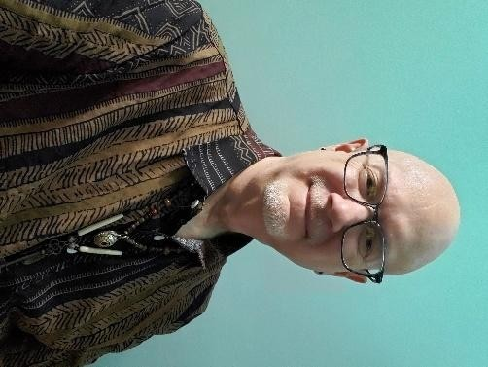
Summer has ended and Autumn is here. Along with the cooler weather and the comfy clothes comes a sense of slowing down. This is a perfect time to take stock of what we want to build and what we need to release. The trees teach us that everything has a season. Society tries to make us achieve and strive year-round. But that is not a natural way of doing things. Just as the leaves turn color and fall, we must allow ourselves time to reflect and release. I encourage you, my reader, to do the same.

A warm thank you to all my contributors! There are some excellent articles in this issue that I know the readers will enjoy. If you would like to be on the direct mailing list for this newsletter, please contact me at deerhorn007@gmail.com to request being added to the mailing list.

Also, to view my keynote presentation for Questers of Canada, copy this link and put it into your search bar:
https://youtu.be/O7-XUcfiz_I

*Please note that opinions and views in articles in FLIGHT are not necessarily shared by the editor, Trent Deerhorn, or Deerhorn Shamanic Services.
Enjoy reading!
Trent Deerhorn

Upcoming Events
From Llewellyn’s Witches’ Spell-A-Day Almanac
Full Moons of 2026
Date: October 26th
Time: 12:12 am
Color of the Day: Silver
Incense of the day: Hyssop

Messages from your Beloved Departed
As the veil between the worlds, things, the Sun in mystical Scorpio and the Moon in steady Taurus enhance our ability to receive messages from loved ones who have passed on. This gentle ritual opens a safe space for spiritual communication.

Gather these materials:
- A white candle (for spiritual connection) in a holder.
- A black candle (for protection” in a holder.
- An item or photo of your departed loved one.
- Dried rosemary (for remembrance)
- Matches or a lighter
- A piece of amethyst (to enhance intuition).
Create a quiet, sacred space where you won’t be disturbed. Place the white candle on your left and the black candle on your right, with the photo or personal item in the centre. Scatter the dried rosemary around the item.
Safely light the black cancel first, stating:

Guardians strong, protect this rite, Surround me with your shielding light.

Next, light the white candle and say:

Between the world, this sacred hour, I call upon love’s gentle power.
(Name of departed), if you hear my voice, Send a sign of your own choice.

Hold the amethyst in your hands, close your eyes, and focus on your departed loved one. Feel the love and connection you share, allowing any messages or feeling to come through without force.
After spending some quiet moments, express gratitude:

Thank you, (name of departed), For your love and light.
I cherish our bond both day and night.

When ready, extinguish the candles. Keep the amethyst under your pillow or near your bed to remain open to messages in your dreams.
-Mat Auryn

Ceremonies with the Shaman
Join Shaman, Trent Deerhorn of Deerhorn Shamanic Services for a special ceremony once a month, hosted by Ki’smet Co,
Saskatoon 16-2220
Northridge Drive. These seasonal and moon-based ceremonies will be centered around going deep and making much needed changes
within. Experience the true magic of Shamanic Healing Ceremonies.
Participants will be required to bring a pillow, blanket and a cushion or stool upon which to sit.
Ceremony will begin promptly at 7:30 pm and the doors will be locked at that time. Please come between 7 and 7:15 so you can have time to settle in.
NOTE: If you arrive after 7:30, DO NOT KNOCK TO GAIN ACCESS. This will only disturb the ceremony that is already underway. Please just join us next month and arrive earlier.
Price: $20/ceremony Cash only, no debit or e-transfers
* If you are not feeling well, please do NOT attend the circle. We like to keep people healthy, not allow germs to spread everywhere.
*It is essential that you pre-register attendance for each circle with Kiernan. Space is limited and there is a maximum of 10 people per circle. If you are pre-registered and need to cancel, please do so 24 hours ahead so the space can go to someone else on the waiting list.
*Once the ceremony begins, participants will refrain from chit chat as that only serves to distract from the energy of the ceremony. These ceremonies are geared toward adults, so it is important to have childcare in place to attend.
To access dates of the ceremonies, contact Kiernan Garvie at
Ki’smet Co at (306) 880-3433 or visit the website at https://www.saskatoonheavenlyreiki.com or https://deerhornshamanic.com

Upcoming Dates:
October 31st:2026: Samhain Celebration. Rhythm Instruments Welcome.
November 21st, 2026: Theme TBA. Rhythm Instruments Welcome.
To register go to this link:
https://www.kismet-co.ca/event-details/ceremonies-with-a-shaman-full-moon-ceremonywith-trent-1-1

Ritual Drum Circles

Hosted by Sherry Crawford of Prairie Girl Therapies
Presented by Trent Deerhorn of Deerhorn Shamanic Services
Take a break in your day to experience the rhythm and magic of a Ritual Drum Circle!
When: Tuesdays at 2:00pm
September 22nd ,2026: Autumn Equinox Ritual. Rhythm Instruments Welcome.
October 20th, 2026: Samhain Celebration. Rhythm Instruments Welcome. November 24th, 2026: Full Moon Ritual. Rhythm Instruments Welcome.


Where: Prairie Girl
Therapies 502a 20th Street West, Saskatoon, Sk. Space is limited, so register early with Sherry to reserve your spot. (306) 914-4968.
Price: $20.00/person. Cash only.
Bring your own rhythm instrument if you have one. If you don’t have one, don’t worry, there will also be extras that are available for use.

Samhain Readings Day

Join Trent Deerhorn of Deerhorn Shamanic Services for a special day of readings.
Using the Scrying Mirror, Trent will receive visions and messages for you to contemplate.
Readings will be 20 minutes in duration with opportunities for questions and answers.
Time is limited, so please be on time for your appointment.
Price: $95.00 Cash, Debit, Visa, MasterCard or Amex
Date: Saturday, October 24th, 2026
Time: 10:00 am – 3:00 pm
Location: Deerhorn Shamanic Services, 230 Charlebois Cres, Saskatoon, SK By appointment only.
Contact Trent at (306) 978-5300 or deerhorn007@gmail.com to book your time!

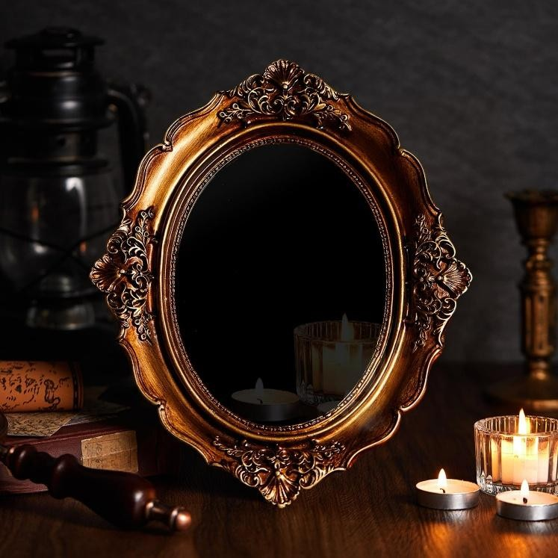

From Over 100 Inspirational Quotes by Alan Chazen
Whatever you put into life, you can expect a ten-fold return. Very much like the reaction you get when you toss a stone into a pond of water and create a ripple effect; so too when you send out messages through your attitudes and actions, you create similar ripples which hit the bank and then return to either bless or afflict your life.

Myths

Among the Ojibwe and the wider Anishinaabe and Algonquin peoples of the northern United States and southeastern Canada, one figure appears at the center of nearly every major story cycle: Manabozho, also called Nanabozho, Wenabozho, or Nanabush depending on dialect and region.

He was sent to earth, according to Anishinaabe tradition, by Gitche Manitou, the Great Spirit, to teach the animals and later the people how to live properly, and he is remembered as both a culture hero who shaped the world into something habitable and a trickster whose schemes just as often caused chaos as solved it.

His most common form was a rabbit. In that shape he was called Mishaabooz or Chiwaabooz, meaning Great Rabbit or Big
Rabbit, though storytellers just as freely shifted him into human form, into other animals, or occasionally into a female role.

As co-creator of the world, he is credited in some traditions with naming every plant and animal on earth, and Anishinaabe teaching connects him to the founding of the Midewiwin, the medicine society at the heart of Ojibwe spiritual life.

He was also, storytellers say, the one who first figured out how to fish and how to record knowledge in symbols, talents that place him alongside figures like the Egyptian god Thoth in the wider pattern of tricksters who double as civilization's inventors.

One of his most widely told stories describes the aftermath of a great flood that drowned the world. Manabozho, floating on a raft with a handful of surviving animals, sent them diving one after another to bring up a piece of the vanished earth from beneath the water.

Most failed and drowned in the attempt. Finally, the muskrat succeeded, surfacing with a small clump of soil clutched in its paws, and Manabozho used that fragment to remake dry land, an origin story often called the creation of Turtle Island.


Rock Talk

By Ave Riddler

ROCKS!!
I wasn’t sure what to write this month, but the rocks that are most on my mind right now are not in my hands. The HUGE Rock and Gem show is returning to Toon town on October 1, put on by Silver Cove and Can Gems this four-day event brings a vast multitude of minerals, some natural, some carved, some
very common but some very rare. Rocks, crystals, fossils, even gem quality cut for mounting all kinds are there. They have gemstone beads, jewelry, low end quality up to museum quality. Some are mined in Canada, others globally. At the risk of sounding like an advertisement, it is an event I eagerly anticipate, watch their page for updates about the next tour, almost as soon as the current one completes. I usually go to it more than once over the four days it is here. They tour in the spring and again in the autumn and it has gotten bigger each year, to the point that the venue has changed from the first time I went to current day. I’m not sure I have missed going to any of them for well over ten YEARS.
(Other than the years when events like this did not happen)
Through this traveling mineral shopping experience, I have gotten a good few of my wish list minerals, lightning struck quartz, Orange River quartz, white jade in tumble form, wulfenite, and various others. I have also ended up bringing home minerals I had read about but hadn’t seen in person, or even more exciting; ones I hadn’t even heard about yet. The experience is more focused on the science of the minerals, but they do have some awareness of metaphysical properties of some types. They often have UV lights so you can see the reaction of certain minerals to the light. If it is a synthetic, manipulated, or lab created they are very clear about that also, so I trust they aren’t trying to scam anyone. In past articles I have said buyer beware, which is why I’m noting I trust them. They do have remarkably fair prices and do not do what I call the metaphysical mark up; single termination quartz crystals can be found for the same price as a double. Yes, they do charge a fee to get in, but even if you just go to look it takes a good few HOURS to see everything, so even then the door fee is more than fair.
I know with minerals being my gift, I don’t seem to get overwhelmed being in that show room, surrounded by so many kinds. I have even joked that I’d love to crawl under a table and take a nap. I will say others I have gone with have had to step out to clear their heads, so if you do go, give yourself time, and BRING water *laughs* drinking water while in that space can help you process the energy of that many minerals, maybe have someone lightly step on your toes to help ground you. I also highly encourage you to have some kind of snacks in the car for after you leave. Remember not all minerals like water, so check before you clean them, I accidentally dissolved a halite crystal because I didn’t know they were water soluble.


Join Ave live online at https://cosmosastrumradio.ca/ Tuesdays 9:00pm Sask. Time.
One hour featuring artists that are currently calling Saskatchewan home, with a diverse mix of singers, song writers, and story tellers.
If you’d love to hear your own music or spoken word played on this unique genre free broadcast contact me at averiddler@sasktel.net

Mudras
Taken from Mudras: Yoga in your HANDS by Gertrud Hirschi
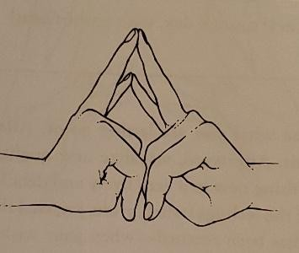
Shakti Mudra
(In honor of Shakti, the goddess of life energy)

Place your ring fingers and little fingers together. The other fingers are loosely bent over your thumbs, which are placed in your palm. Focus on your breather in the pelvic area, and slow down exhalation somewhat.
Do as needed, or three time a day for 12 minutes. The Shakti Mudra intensifies the respiratory impulse in the lower chest area. You can increasingly perceive breathing in the pelvic area. It has a calming effect and will help you fall asleep at night. If it is done too often or held for too long, it may also lead to lethargy. It can bring pleasant relaxation to the pelvic area. As a result, it can counteract spasms in the intestines, or even menstrual complaints.
I am frequently asked for advice about difficulties in falling asleep. One of the following tips always works:
Practice this mudra in a slightly different form before trying to sleep. Of you sleep on your sides, you can take a corner of the pillow between your hands, place the little fingers and ring fingers together, and let the others lay on or beneath the pillow.
Bend one hand back and slowly turn it to the left and to the right six times; then to the other hand; then one foot, and the n the other.
Moisten the outer and inner sides of your legs with a wet cloth/ go to bed without drying them.
Affirmation: Silence, harmony, and peace fill my entire being.


This is Canada
Canada is the second largest country in the world. It is incredibly diverse and often looks nothing like people imagine it.

This isn’t Rome. This is Canada (Montreal)

PEEVISH
By Ave Riddler

Waking in a room much lighter
Than it should be
Must have turned off your alarm,
Small panic as you fling the blankets
Try get out of bed and a foot tangles with the sheet.
You almost fall but save yourself.
Glad that's done you hop in the shower Realize you forgot to buy more soap Make do with shampoo.
Dripping you reach for the towel
You took to the washing machine last night.
Trailing water
And bare you get a fresh towel from The closet down the hall.
The pants you were going to wear Have a big tear in the back No idea how THAT got there.
Finally dressed,
Go to start the coffee,
Only enough grinds left for a cup.
Start packing lunch and the fly on your jeans
Gets stuck on the cupboard door handle. Forward motion abruptly halts, Choice words said.
As you reach into the pantry
You hear a ripping sound as you
Get snagged by the loose nail in the door frame That you keep meaning to fix.
That's where the hole in your pants came from! Finally ready
Congratulating yourself you're not leaving late
Low air light warning for your tires is on,
You check it and should be safe to drive,
The closest place to fill it is
Twenty stressful minutes away.
Halfway there,
Blasting tunes trying to calm down, There's a train stopped on the tracks.
Is there a reset button?
Do you really need to go to work?
Air in tires
Coffee gotten at the gas station while dealing with the tire.
Finally get to work
Only a few minutes late And remember it's a stat holiday You didn't need to go to work today.

Tidbits and Tickles:
It is my first week working at the bicycle factory and they already made me a spokesperson.

THE ART OF ENERGY SOVEREIGNTY
Continuing the Exploration - Experiencing the Practices
By Sharon Whitethunder Baldock
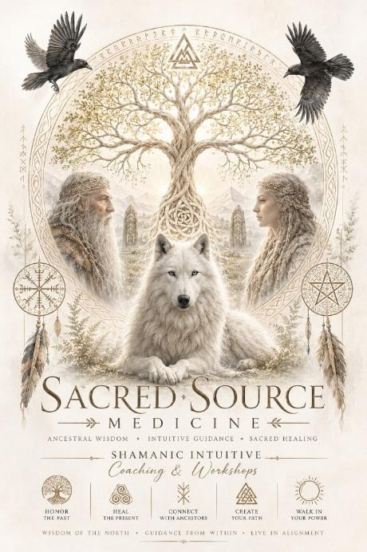
When it comes to the healing path it is extremely important to practice self care methods and tools. Without them we can spiral into deep depression, chaotic and challenging life events or even worse...start medicating our feelings. Medication has its purpose ...for a time, over a longer period of using drugs it can create a huge chasm in our psyche, our spiritual connection to who we are, suppress deep emotional trauma. This can lead to years of suffering when we suppress emotions or trauma that need to be healed. It can also create a blockage to our abilities and spiritual journey....our purpose
In my opinion the medical system creates dependency on foreign medicines that are not natural for the human body. I believe that health issues are a sign of our body trying to get our attention to look deeper within us to heal.
On the spiritual side there are different symptoms that signal what to look for that needs to be healed. Even more important to recognize when those symptoms or health issues have had numerous medical approaches where it cannot be diagnosed or it just doesn't make sense because your living style has always been healthy.... or has it? Maybe you have had procedures that have only made things worse. Maybe you feel something inside emotionally that you thought you dealt with...yet those memories still have a hold on you in some "unknown way." It may be that you feel a deep yearning to be or do more to find your path.
Until we understand and learn that we are affected externally by outside influences, it will only continue and compound the problem. Everything in this world is energy, WE are energy, emotions are...energy in motion. I know how difficult it can be to get moving or motivated and I have learned to differentiate when it’s a time I need to sit in stillness, be compassionate, follow my desire or do something within my tools of self care. Most of the time this is a trauma response. The worst thing I can do its to scroll or go onto the website and query ways to get out of the funk I'm in. Especially listening new age ideals and others who have no idea how far I have come and how I need to be approached. I am not of that group that thinks "all you have to do is think positive," "meditate on it," or "you asked for this life" etc....which I think is absolute bullshit...which is another blog.
The only way out is through...it’s just that simple. Knowing and practicing tools when we are ready to receive guidance is where it begins...and it can start no matter how young...or how old. If we looked a life as energy rather than time it wouldn't seem so insurmountable and difficult. We have moments of clarity and moments where things are unclear...and that's okay...nature does this all the time. Not everyday is sunshine, the clouds never appear in the same shape, and we can never touch the river or body of water in the same way ever again. Nothing stays the same...because EVERYTHING is energy.
I have been doing A LOT of Candle Ritual Banishment this year to clear darker energy from my family, work and hometown. I must admit I was a bit skeptical at first and not as confident, but within weeks I saw and experienced a much more peaceful, hopeful and productive energy around us. Our words and intention hold great power. It takes practice to ensure our rituals have the weight and power behind them. And that is the same for anything when we practice, it’s not about perfection, it’s about consistency.
Banishment Candle Ritual is not about causing harm necessarily, it can have an adverse reaction but that is because they choose to create the dark energy to others and it comes back to them. It does not mess with someone's energy, and most practitioners will not take that approach. I have had people misunderstand or interpret this magic in a negative light. Doing this type of magic returns the energy to them and, like all things, karma has repercussions. There must be consequences for the actions they create towards others. This is also about banishing the energy causing you problems...or harm.
In other parts of self care, we cannot allow things to "take root." When we have direct or indirect altercation with a person or indirectly, we create a cord in thought...or deed. Every interaction creates an invisible energy cord to us and that can cause a few issues. Our mind will continue thinking about the issue, we may lose energy... feel tired all the time, we may experience difficulties and challenges, or we can become more un-grounded, have unclear thinking, be imbalanced or not ourselves. There are a few methods to learn how to cut cords but it’s important to pull the cord out from the root and not just simply cut the cord.
Sometimes we need help in navigating this method because if you haven't cleared or protected yourself properly you may only get part of the root.
Beginning this spiritual journey takes practice...daily and weekly...seeking the inner wisdom means doing the healing work. The more you let go and release .... the more of what you want, or desire will grow within you. Again, this is not about perfection.... it’s about practice...and not every session or practitioner will have the exact knowledge or information. Practice...takes compassion, clarity, understanding, patients and time.
The Art of Energy Sovereignty - Continuing the Exploration - Experiencing the Practices Is a one-and-a-half-hour free talk... that will be more experiential!
We will overview the previous Energy Sovereignty talk and expand on the importance of clearing and banishing unwanted energy. I will facilitate a clear, center, ground and balance meditation, a Medicine Shield, and Pillar Protection. Following this, I will guide you in a hypnojourney to help you navigate to a realm of the wise ones. Here you can ask for messages, guidance, direction or maybe some healing. Keep in mind that the spirit world does not recognize our mundane way of life with time.... what we see as time...is irrelevant in their world.
I will briefly speak about the upcoming workshop,

Clearing & Banishment: Practical Shamanic Methods
Unwanted Energy, Everyday Protection & Candle Rituals
In this one-day workshop you will learn Shamanic tools and methods to clear unwanted energy and banish dark or toxic energy through candle magic.
This event will take place Sunday, November 1st 10:00 am - 8:00 pm (2 - 30 min breaks/ 2 - 15 min breaks) Investment:
Early registration before October 16th, 2026 - $250. After October 16th, 2026 - $300.
Once you register, as a group we will decide if we want to do this in person or via Zoom.
Candles, manual and booklet are included
To register for “The Art of Energy Sovereignty” talk
Contact me directly by October 1st at whitethunder000@yahoo.ca Sunday, October 4th, 2006, 7:30 pm.

From A Guide for the Advanced Soul, by Susan Hayward
Life’s fulfillment finds constant contradictions in its path; but those are necessary for the sake of its advance.
The stream is saved from the sluggishness of its current by the perpetual opposition of the soil through which it must cut its way. It is the soil which forms its banks. The Spirit of fight belongs to the genius of life.
-Ragindranath Tagore

From Hex and Shadow Chronicles Iron

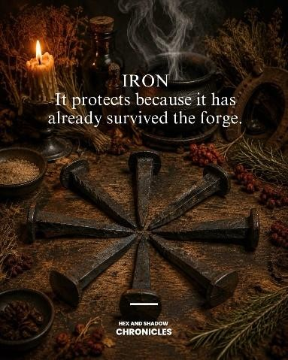
Iron has carried a reputation for protection for centuries. Across British and European folklore, iron objects were placed near doors, windows, beds, cradles, and other vulnerable thresholds to guard against harmful supernatural forces.
The horseshoe became one of the most famous examples. Hung above a doorway, it was believed to protect the household and repel misfortune. Iron nails, knives, scissors, and other everyday objects also entered folk practices surrounding protection. Iron became particularly important in stories about the Fae. In later
folklore, “cold iron” was often described as something fairy beings disliked or could be repelled by. This association varies enormously between traditions, but it helped establish iron as the material of the human world standing against supernatural intrusion.
There is something beautifully practical about this form of magic. Protection did not always require a rare herb or elaborate ritual. Sometimes it was the nail already driven into the door, the horseshoe above the entrance, or the iron object kept close to somewhere vulnerable. Modern witches sometimes continue this symbolism by incorporating iron into wards, protective charms, boundary work, and home protection. An old iron key may represent control over who crosses your threshold. An iron nail may be incorporated symbolically into a protective working.
A horseshoe can become both a folk charm and a reminder that the home is guarded. Iron carries another powerful symbolism too. It comes from the earth, survives fire, and becomes stronger through the work of the forge.
Earth.
Fire.
Transformation.
Protection.
Perhaps our ancestors did not need expensive magical objects because magic was already woven into the materials surrounding them.
Sometimes protection looked less like a spell book and more like a piece of iron beside the door.

Taking Responsibility for Our Nature:

How the ULT can help you manage your spiritual gifts
By Loriann Zuzak

Did you know your spiritual gifts can be identified on sight?

Your physical body is full of clues about your natural, behavioral potential - including your spiritual gifts. Whether you have the capacity for flash perception insight, naturally access deep empathy, or are prone to divinely inspired ideas, the Ultimate Life Tool (ULT) Assessment can give you precise, refined information on your own natural perceptual abilities. It can lay out what you innately have access to, whether you seek to further develop and hone the skill or not.

How this serves in my coaching practice

Often when individuals come to me for coaching, we find that the inner experience of selftrust they are longing to create requires a more attuned self-understanding, validation for their own instincts and acknowledgement of their receptive nature. Building a better relationship with their own intuition is a necessary part of that - particularly for women who have downplayed or rejected their feminine, intuitively responsive aspects in favor of a more corporately acceptable posturing.

My first experience with the ULT

I have been on a journey to self-understanding much of my adult life. When things turned upside down during the interruption of 2020, I found myself looking for something that would differentiate my work from other life coaches. After a series of strange synchronicities, I came upon the work of Dr. Zannah Hackett and her Ultimate Life Tool Assessment. I was so impressed by the revelations the portal experience registered in just two hours together, that I committed to train through all three levels of her certification. Her assessment measures the physics in the physical make up of a human being and creates a behavioral profile called a “grid” which I am now trained to interpret. Even without the grid, her TYI Certified Life Coaches are also trained to provide these insights on sight - recognizing behavioral potential just by looking at people. This work gives the individual experiencing it breakthroughs in self-understanding in all areas of life. As a spiritual seeker, I was most drawn to the way the knowledge lays out an individual’s intuitive abilities and processing gifts. I’m going to spend the rest of this article writing about how the knowledge has informed my own self-understanding (using the example of my resistance to groups). I hope to help you begin to see how it can inform you as well.

How quickly do you process information? How does incoming information move through you? How do you experience an inspired idea? What do you hold onto? Is it easy for you to detach?

We use the concept of “processors” in this knowledge I work with. We say there are three types and depending on which of the three or in what combination they appear in your grid results, we will know more or less how psychic you are, how empathic you are as well as how others naturally experience your healing presence when they are around you. We will have a clear sense of how you open to your clients (and interestingly, we can also get a behavioral understanding of the typical client that will be drawn to work with you). We will have a sense of whether you can work in a healing modality and naturally not take on the clients’ “stuff” and when more self-mastery around letting go will be necessary. We have a sense of how information you’re getting is an experience of a perceptive, absorptive or inspired style of processing.

Managing yourself and managing your gifts through the Knowledge.
Are you really in the right frame of mind and energy to help others today?

We all know the importance of staying centered and in right relationship to self and others when working with others, particularly in the helping professions. Most spiritual praxis is the work of grounding and settling yourself to be present, aware and heart-centered for the work at hand. The ULT is a powerful tool for self-awareness and masterful self-adjustment when energy drain comes online. Watching and noticing the energy drain is important because that’s when inauthentic (less than desirable) behaviors will naturally start to come online for you. Different gifts require different behavioral self-care. They demonstrate an energy drain in very predictable ways that are easy to spot and correct once you’ve been made aware of how they unfold.

People with empathic gifts can find they easily fall into feeling sorry for themselves or inappropriately hanging onto the problems of others. Highly perceptive people can seclude themselves, experience a severe inner cruelty and find themselves feeling extremely intolerant of others. Divinely inspired people, when at their worst, can drown in their own self-absorption hardly noticing the effect they’re having on others around them, behaving in a childish way when confronted by information that balances out their naturally positive and optimistic take on life.

These types, when at their best, can sit with another in pain, witness and stay in right relationship to another who is struggling without robbing them of their agency. These types can actively point out what’s not working in a failing strategy that others are struggling to diagnose. And when others are overcome with negative perceptions of themselves or their lives, these types can also provide a light into all the good and possibilities that others are not seeing.

Once you understand which processors you naturally have access to, you’ll be able to see yourself when you are operating in a balanced way and self-recognize when you are having an “off” day. This is powerful for self-management, knowing when you’ll have to take extra care of yourself to right your ship before you reach out to help another.

Taking responsibility for the energy you bring into the room.

Using the ULT in your personal self-management lifts the burden of the recognition of your “off” day being placed on those around you. You’ll find yourself not having to be signaled by others to self-correct.

What if internal self-judgement coming online in you was just a signal rather than a bad attitude?

Throughout my life, although drawn to spiritual environments, businesses and all kinds of healing modalities, I’ve always felt like I didn’t fit with fellow travelers in these kinds of spaces. I’ve been resistant to participating in groups. In the past, when I have had to participate in a group setting, I have had the inner experience of feeling impatient, intolerant and restless - which is odd because I consider myself to be a mostly kind, caring, wholehearted person (most of the time, but not all of the time). I would reflect in my discomfort and remember, “I really wanted to be here. Why is it feeling like this?” For years, I assigned myself a diagnosis in those moments of “having a bad attitude” and felt shame for the way I was feeling inside in comparison to what it seemed others were experiencing around me in the same space. I did shadow work to understand and integrate what I was seeing in the others that was “mine” (which was helpful). But I still assumed that every time I felt resistance, that there must be something wrong with me. There was more I was not seeing. The issue was in the style, pacing, and resonance created by a more concentrated grouping of predominantly one type of processor. We can all be in the same space, sharing the same moment, having a completely different experience of the moment. The knowledge I work with can explain why the feeling of “disconnect” and why the feeling of “not belonging”.

What if you could provide yourself with the validation and reassurance you keep hoping to get from others?

According to the ULT, there are ways we affect each other whether we are directly interacting or not when in proximity. Now that I have the knowledge for myself, I no longer compare myself to others or judge my inner experience when participating in a group. I can easily see and understand what’s happening when that sense of energy drain comes online in me. The ULT helped me understand what was going on in my own being - that irritation, restlessness and sense of wanting to explode for no obvious reason became valuable feedback. It helped me map my honest internal experience of self with objective reasons why this was occurring. When this happens now, I don’t devolve into the over-thinking and internal distress I used to feel. I understand what’s going on. I acknowledge my experience. I know how to adjust.

Depending on the time of day, the nature of our own being, we can experience energy drain just by being in another’s presence. It’s a matter of physics. The thoughts and feelings that one experiences can be seen as objective feedback about electromagnetic changes occurring in your body in relation to others built differently than you are.

Freedom from over-thinking and the auto-assumption that the experience I’m having must be “wrong”.

Having this knowledge for myself has removed much of the self-criticism and second guessing I used to experience internally when trying to participate in groups. It’s not always one’s attitude; many times, it’s just the way you are built. Some experiences of energy drain don’t require any over-thinking or re-processing of your intentions, attitude or the spirit of your engagement. You don’t always need to go back over old territory you’ve been through before in your personal work. Understanding these interior signals objectively is a boon to the individual who takes special care to be self-aware and accountable for the energy they bring to a room and to the people they choose to interact with. It can interrupt an overthinker’s pattern of self-recrimination and bring serenity back online quickly after an internal upset.

Understanding this has been huge in navigating my interior life while relating to others. It has helped me understand the value I naturally bring to the moment when working with others. It has helped me understand how my gifts work and how to further care for myself in my continued unfoldment and personal growth. And last, the work has helped me recognize and appreciate when I’m fully operating at my best.
Interested in having your own experience with the ULT? Licensed and certified to offer the ULT Assessment in my coaching practice, I help seekers to deepen their self-understanding, appreciate and navigate the challenges of their unique gifts. Visit https://www.alchemiawisdomschool.com/ to learn more.

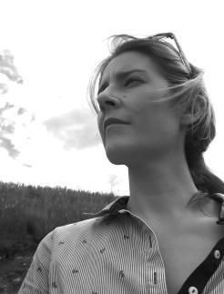

Loriann Zuzak is a writer and transformational guide whose work explores memory, mortality, emotional legacy and the quiet importance of feeling truly known. Drawing from her own well of precious lived experience, spiritual study and professional certifications, she is the founder of a modern wisdom school. To find out more visit loriannzuzak.com.

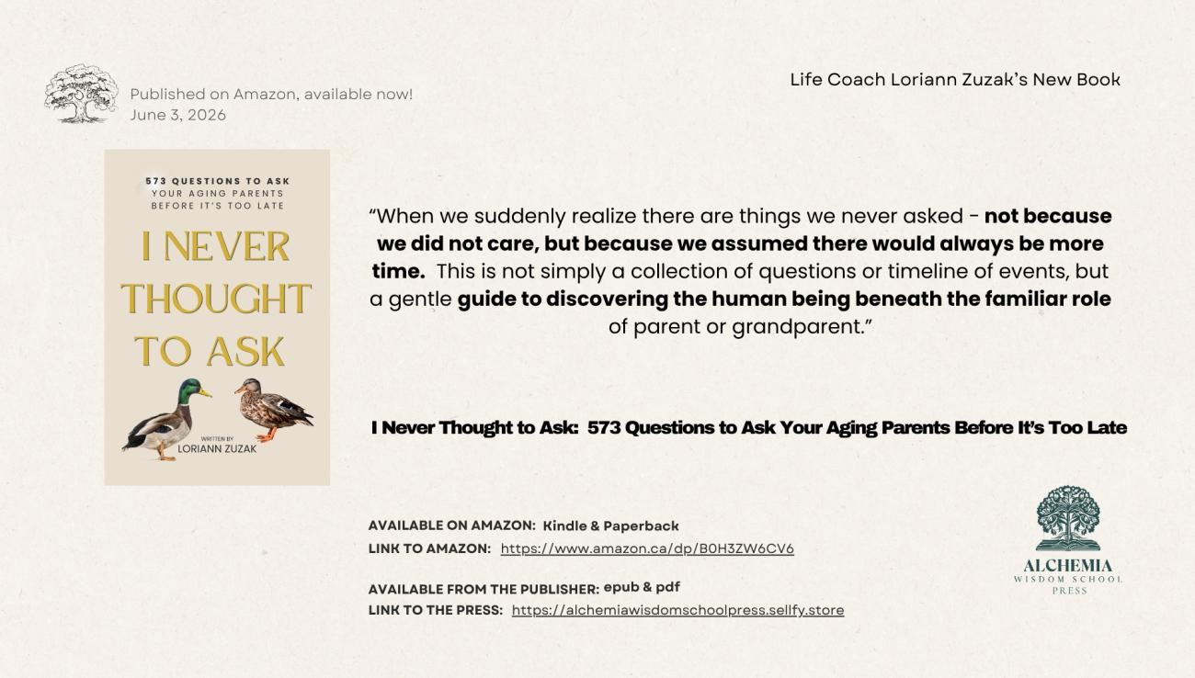

FROM EARTH TO ETERNITY
By Gail Fulkerson
The elderly gentleman made his way slowly down the street with his walker. He was heading home after being at the grocery store to buy tomatoes and milk. He had plans to make tomato soup, but that was as far as he got before he clutched his chest and keeled over. He was dead before he hit the sidewalk.

He stood and looked down at his prone body and wondered how it was that he could see his body but not feel it. That’s when a man walked up and checked his body for signs of life but couldn’t find any. He pulled out his phone and called 9-1-1.
Minutes later, an ambulance arrived. The attendants got out and checked the body for signs of life, but there were none. They loaded the body into the back of the ambulance and drove away, heading for Royal University Hospital. At the last minute, the older man hopped into the ambulance and wondered why no one was attending to him. And where was his walker? He’d need that after the doctors and nurses deemed him a little shook up and discharged him.
He tried to get back into his body, but it was as though all the doors and windows were shut and locked against him, and he couldn't get back in. He was about to panic when a Light Being appeared beside him and told him not to worry; everything was unfolding as planned. The Being explained that he’d died and that was why he couldn’t get back into his body. Time had run out, and there was no turning back the clock.
The older man wanted to cry. He had plans for the rest of today and the week ahead. He supposed the plans didn’t matter now that he was dead, and he was right. He stayed with his newly vacated body until they wheeled it into the morgue and began prepping it for autopsy. He tried to tell them he’d had a massive coronary in the street, but no one seemed to hear him, no matter how loudly he spoke. It was maddening.
The Light Being was by his side again. “I don’t think you want to stay for the autopsy, Fred. It gets gory after the incision is made, and I don’t think you have the stomach for watching the coroner put his hands all over your innards. Let’s get out of here, shall we?” Fred agreed with the Light Being, and they left the morgue. The pair ended up at Fred’s house. The two of them floated through the walls and into the living room. They each took a seat on the settee; one on one end and the other opposite.

“What now?” asked the old man of the Light Being.
The Light Being pondered the question and formulated an answer he thought the older man would understand. “When you died on the street, your soul left your body. The silver cord was severed, which is why you couldn’t get back into your body. Was there something here in the house you wanted? Remember, you can’t take anything with you.”
“I know, I just wanted to take a final look around the place, but I don’t remember why it was so important that I did,” commented the older gentleman.
The Light Being took the man’s hand, and together they floated through the ceiling and into the night. The Light Being took the older man on a tour of the town he lived in, a final farewell to an earthly life.
“Thank you for the final tour,” the older man said to the Light Being, as they rose higher into the night sky. The town’s lights below glowed and twinkled as the pair ascended; then they were lost in the twinkling lights of more towns and cities the higher they went. The two of them were floating high above the clouds as they looked down a final time upon the Earth, the older man’s home for all his 90 years. In a blink, they were in another realm, one of diffused light that was easy on the eyes and seemed to come from everywhere. As the older man acclimated, he noticed his ethereal body had a faint glow that brightened as he watched. His corporeal body faded away, absorbed by the glowing light surrounding him. He became a Light Being.
“Welcome home, Fred. It’s great to have you back,” said the Light Being. “We will have a homecoming party for you after you’ve rested. Not to worry, we won’t start without you.” The older gentleman yawned and lay down upon a bed that seemed made of clouds; it was so soft. He fell into a deep, dreamless slumber. He was finally home again.
The man slept peacefully and awoke years later, refreshed. There was no more pain from aching joints and tendonitis in his shoulders. He found that he could walk without the use of his walker; his body healed and felt like he was in his prime, which he was. His glow had also brightened with rest.
As promised, Fred, the newly created Light Being, was welcomed home by countless Light Beings; the party lasted for weeks. Every soul had a fantastic time, but none more than Fred.
A new soul was being welcomed back. Fred was front and center, welcoming the newest member to the group.
The crowd sang, “Welcome home, Vera!” Vera smiled widely, thanked the group, then told them she was tired and needed to rest. They bade her a refreshing sleep and let her go.
Transition is quick and peaceful for all souls once they’re on the Other Side. It’s done and over with in the blink of an eye; at least it seems that way from the perspective of a newly minted soul.
It happens to all of us, sooner or later.
I prefer later.

From Llewellyn’s Witchy Calendar 2026
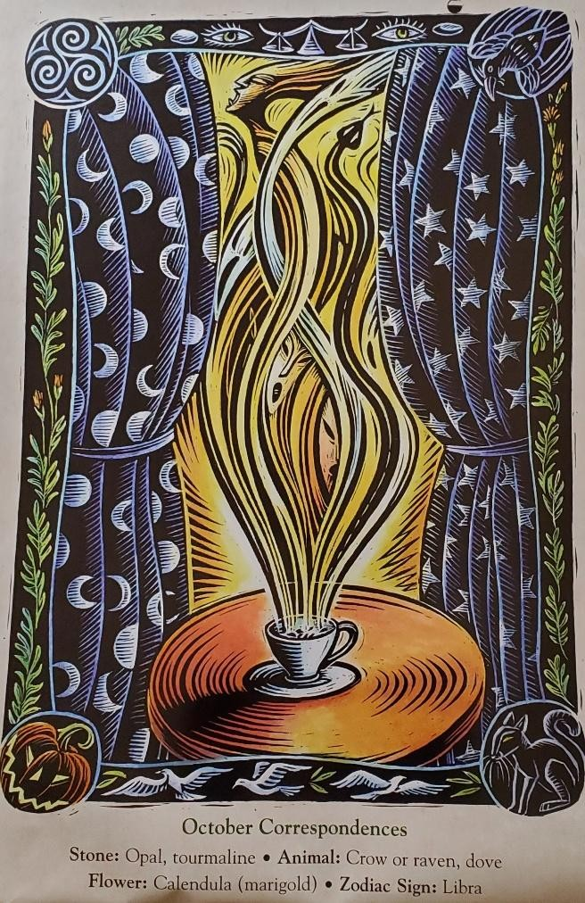
October

The nights grow darker, the cold begins to creep into our homes, and winter is so very near. This is our last chance to fully enjoy autumn before the long nights truly take hold. It is in this month that we see a rise in all things spooky as Halloween draws near. Most Pagans today associate the end of October with the celebration of Samhain. The work Samhain has come to us via a Gaelic festival, and while it is true that Halloween and Samhain are not one and the same, today these traditions tend to blend for modern-day Pagans and Witches. Samhain is not the only celebration found at the tail end of October. In Wales we celebrate Nos Galan Gaeaf on October 31. Nos Galan Gaeaf translate to essentially mean “The Eve of
Winter” or “Winter’s Eve.”
The first of November marks the start of winter in the Welsh calendar, and so the end of October is viewed as the final goodbye to the lighter half
of the year. This is a liminal time, a time when fearsome spirits lurk in the shadows, when ancestors are remembered, and when ordinary folk play divinatory games. This was considered an opportune time to divine the future, and so when better way to welcome October than by diving into that stream of tradition?

Tea Leaf Reading
The types of divination that were carried out at this time of year varied from region to region. My Nain (grandmother) was a tea leaf reader, and so I always associate this time of year with reading leaves.
You will need:
- Loose-leaf tea of your choice
- 2. Teacup with a dish
Make yourself a cup of tea with the loose-leaf tea of your choice. Allow it to cool for a moment. Before drinking the tea, place your palms over the top of the cup, close your eyes, and recite the following invocation: Veils that divide
We ask you now part. Open the ways For my Magical Art.
Sip the tea, all the while contemplating any questions you might have regarding your current life situation. Is there anything going on in your life for which you would like some clarity?
Once you have finished your tea, tip the cup upside down onto the dish and turn it three times clockwise. Tap the bottom of the cup before lifting it up and looking inside. What shapes do you see in the cup? Try to decipher a story from the shapes the leaves have left, and this is your reading. For example, a shape resembling an envelop could be a sign of good news coming your way. Or perhaps the presence of a snake with a forked tongue indicates that someone near to you is speaking ill of you, and you need to be wary. What do you see in your cup?
-Mhara Starling


Marina’s Divination Station
By Marina Evans
Hello one and all and welcome back to the Divination Station!

Spooky season is upon us and I, for one, am already enjoying the crisp air and smell of the changing season. This has always been such a great time to look back on the summer months and being our hunkering down for the cold winter nights. Yes, of course, we lament the warm days of not having to bundle up in
several hundred layers just to go outside, but at least in the moment right now, we have some warmish days left with evenings perfect for fires in the backyard. I feel that this season is also a more somber season. With the veil thinning and the world preparing for its slumber, we sit back down at the table with ourselves and replay all the choices and actions we have made that we were just too busy to look at while the sun was shining. But that’s not a bad thing. Sometimes slowing down and analyzing ourselves can help us find ways forward in the world. At least that seems to be the message for this month’s tarot.

BEETLEJUICE TAROT by Casey Gilly and Abigail Larson

Well, if this isn’t the perfect time of the year to introduce this deck then I don’t know when is! This deck is so much fun with recognizable artwork from the first movie to help you replay all your favorite moments and even glean some guidance for your own lives and situations. The cards are a heavier card stock and a matte finish which can make for a harder shuffling card, but once you break them in a bit it’s no problem. The artwork is brilliant and the box leaves nothing to be desired, but one thing I do have to talk about is the guidebook. If you are the type of person who loves a good guidebook, this might not be the option for you. It’s short and to the point which I have no problem with, but the whole thing is written on a fold out poster sized card. This makes referencing it a bit clumsy and cumbersome, which I wouldn’t mind if there was some kind of actual poster on one side, but there is not. So, for every other part, it’s fantastic, but don’t put too many expectations on the guidebook.

The Drawing of the Card

XX - Judgement

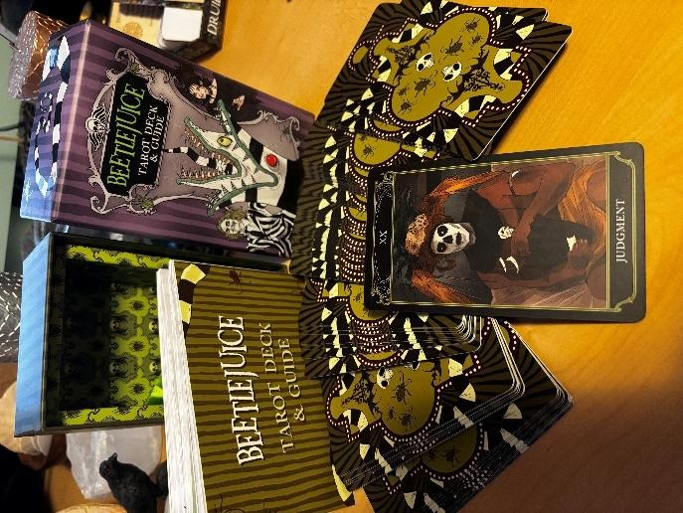
Judgement is always an interesting card to pull because its meaning can differ quite a bit depending on what is around it. But to draw it alone really seems to emphasize self-reflection. Now is the perfect time to spend time with the things you have done and situations you find yourself in and assess your role in them. Sometimes it’s easier to point the finger elsewhere and absolve us of responsibility, but nothing changes and we cannot grow if we aren’t accountable. Look into different parts of your life where you are struggling, and see what you could have, or can do, to make them better. What was your role in things not turning out how you wanted? This doesn’t mean that you need to tear yourself down, or beat yourself up, only that taking accountability for your part will help you grow emotionally and spiritually. It’s a great time to think about what we could have done differently that may have benefited us more, or what we can choose to do differently in the future. We can change the past, but if we don’t learn from our mistakes, we are doomed to repeat them. Look at yourself honestly, and you might find more compassion for yourself and others than you thought possible.
If you have enjoyed this reading, and want to explore more decks, follow me on Instagram 29crows and let me know which deck you’d like to see next!

Until then, Breathe.

For the Love of it,

Marina

Reflections from the Shaman's Hut

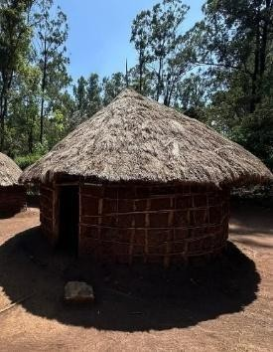

ART

By Trent Deerhorn
From the time I was
very young I have enjoyed art. Colors, textures and compositions have always fascinated me. But something that I have enjoyed even more is the fact that when I am doing art I go into a trance state of consciousness. This has happened consistently from the time I picked up my first crayon. I would color or draw and hum away to myself and the next thing I knew I was completely somewhere else and in some other time. One of my children also has this gift and accesses it when doing art.
I thought that this was unique to myself until my mother noticed that I was completely someplace else whenever I was drawing or painting. She mentioned that she also would do that whenever she was creating something. And my grandmother would as well. It did not matter if it was drawing, painting or cross stitching, they would go into a trance state.
Later, when I was learning from a Shaman in my mid-teens, I mentioned this to him. He informed me that for thousands of years Shamans would use art to access the Dream Time and would find answers to questions they had.
For example, if the hunters were setting out on a hunt, the Shaman of the cave would paint what they were hunting. As he/she painted it, they would tune into where the herd could be located, thus making it easier for the hunters to have a good bounty.
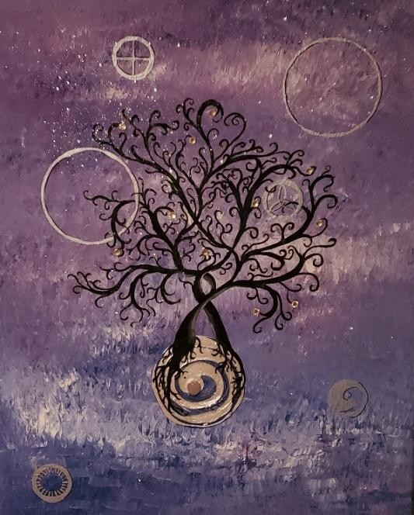
I have found, over the years, that my art has changed. Sometimes it is ethereal in nature, sometimes more primitive. But the thing is that it is all done in a trance state. Many of my paintings have been done with my eyes closed or blindfolded. That way there are no other distractions. And this also allows me to go deeper within so that I can access deeper levels of consciousness.
I encourage you to try this out, a little at a time. You don’t have to be Picasso or Van Gough to have success with the technique. You must simply be willing to attempt it and practice it consistently.
For more articles by Trent, check out his blog at www.deerhornshamanic.com.

According to the Farmer’s Almanac 2026:
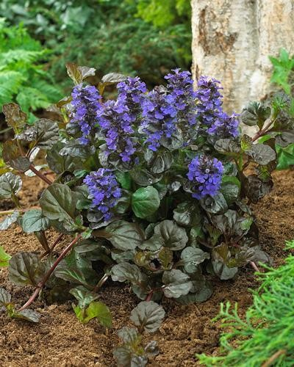
The Dark Side
Plants with dark purple to black flowers and foliage are fast becoming a gardening trend. “Black Scallop” bugleweed’s burgundy-black leaves creep over the ground as if to envelop admirers in darkness, while “black Knight” hollyhock, “Black Delight” viola, and “nightrider” lily all look like blooms from a fairy tale villain’s garden. “Black Adder” phormium and “Aloha” Colocasia both feature dramatic dark foliage to nestle among like-colored companions or as a striking contrast to bright yellow or hot pink flowers. Experiment with textures and
patterns, keeping in mind that although these dark beauties may look like shade-lovers, they will dazzle in full sun.



October 10th: New Moon


October 12th: Thanksgiving Day (Canada)


October 26th: Full Hunter’s Moon


October 31st: Halloween

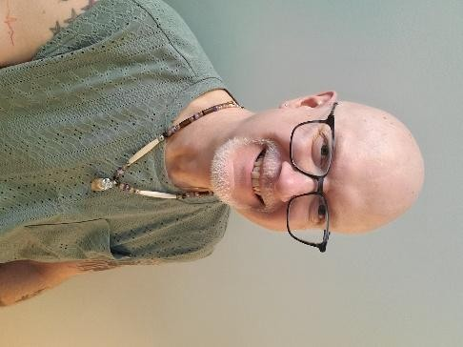
Ask the Shaman: With Trent Deerhorn
Q: If a person feels that their home may have some spiritual presence happening, what can one do about it to get rid of the spiritual presence?
A: Something I have learned from when I was just entering my teen years is that it is important to discern whether it is a spiritual presence or an energy disturbance due to someone’s (usually a teenager) kinetic energy erupting along with the hormones erupting. My parents thought that our house was experiencing a
haunting, but it was my own kinetic energy growing and expressing itself in my sleep. It is an easy error to make. We had a well-known witch come in to clear the space, but she took one look at me and said, “It isn’t a ghost, it is him.” So, she taught me how to get more in control of my own energies.
Once it is clarified as to the cause of the disturbance, and if it is in fact an entity haunting, then it is important to have the space cleared and blessed. Some prefer to do that with the help of a priest. Others prefer to address that with the help of someone like me, a shaman, or a witch. The thing to remember is that this cannot be their first rodeo with space clearing and blessings. You need someone who knows what they are doing, no matter what the approach may be.
If it is not an entity haunting and is kinetic energy gone wild with someone who lives there, then it is important to have them experience an Energy Balancing healing. This is, again, is not something for an amateur. Energy Balancing has some very technical aspects to it. Make a wrong move with it and matters can get worse and escalate fast when it comes to kinetic energies. So, choose your helper wisely.

Forum
We like your feedback! Of the previous issue:
Mark Wrote: I enjoyed that article on Pan!
Celeste Wrote: I love the idea of doing Dream Work!
Betty Wrote: Zoisite is so gorgeous!
resonate with your Time Will Tell article.
Bobby Wrote: Oh! I really appreciate your approach when it comes to working with people with addictions.

Classified Ads

Video Chat with the SHAMAN!

As part of my Shamanic Practice I have, for years, provided long-distance healing work for people. This sometimes comes as an energy treatment and sometimes as a telephone counselling session. Well, now there is even another option available! We can now have sessions on Face Teams, or Telegram, and you can speak to me face to face! If you are interested in this option, simply email me at deerhorn007@gmail.com or phone me at (306) 978.5300 to book an appointment. Blessed Be!






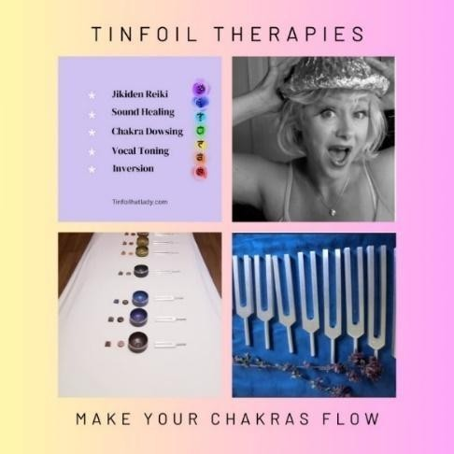

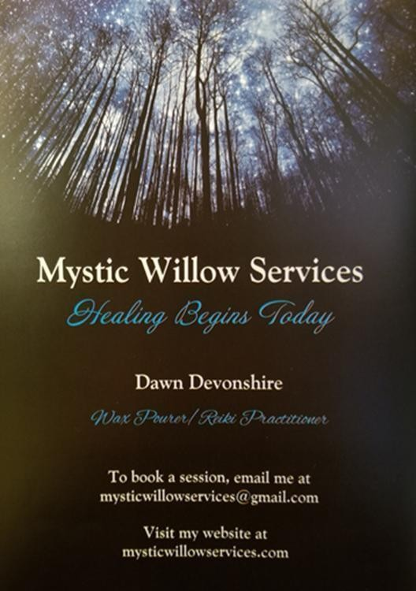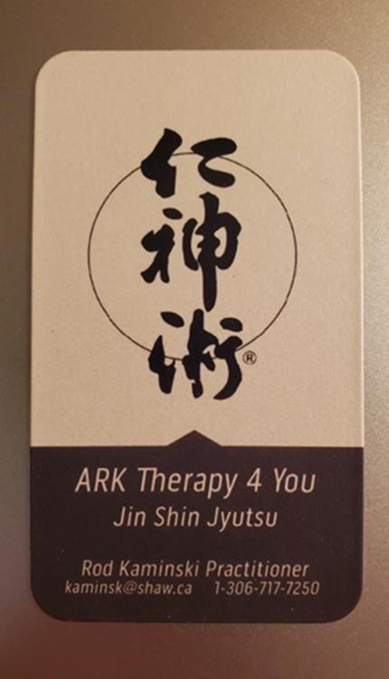
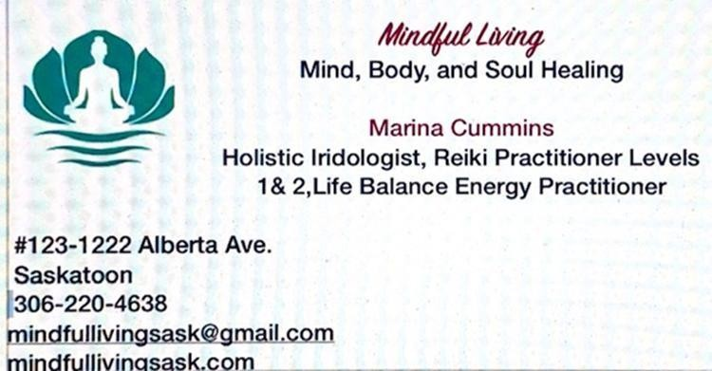

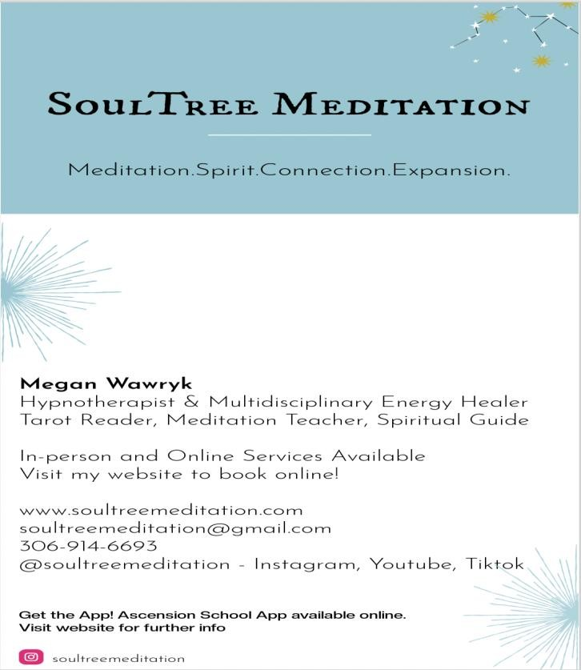
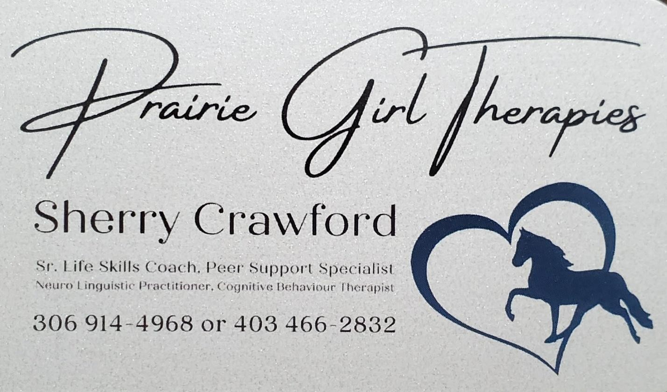




Flight Newsletter Advertising
All ads must be in by 6pm on the 20th of the month PRIOR to the issue that the ad is to be placed in. No exceptions. Send to deerhorn007@gmail.com.
Classified Ads:
FREE for article contributors
$45 for business card size
$55 for half page.
$70 for full page
Events: FREE for non-profit organizations and Article Contributors
$25 for Profit organizations
Workshops/Classes

$40 half page$50 full page

