Flight: A Living, Breathing Document of
Consciousness
Volume 14 Issue 148
November 2025
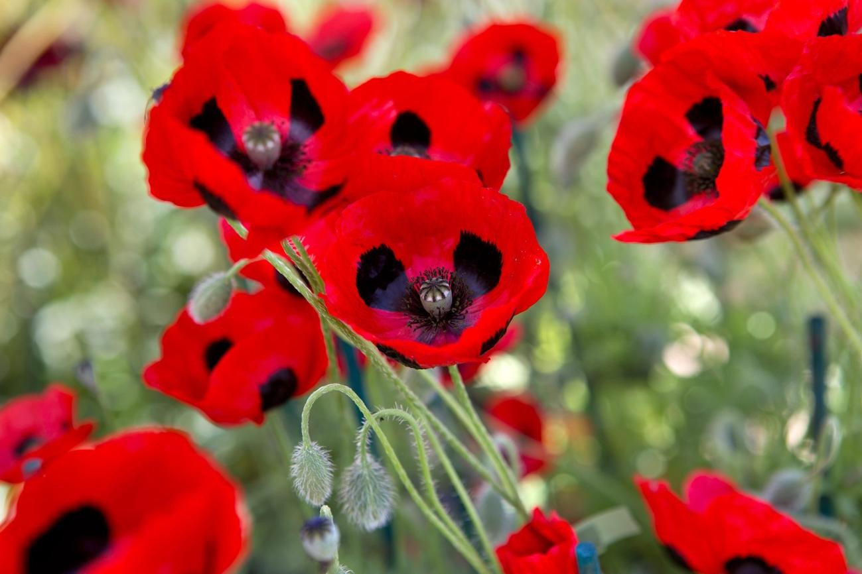
Articles that inform and inspire!

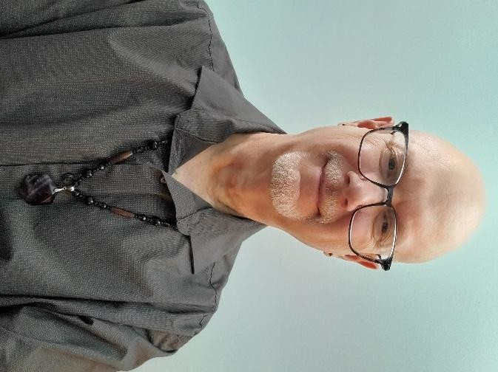
Letter from the Editor
November is a time when I have put away my Spring and Summer attire and have brought out my Fall and Winter attire. For me it is a time for snuggling up in my easy chair by the fireplace and reading a good book while sipping on a hot drink and wearing a cozy sweater, with one dog either on my lap or squished between my thigh and the arm of the chair, while another dog is curled up at my feet. Sometimes the third dog jumps onto my lap as well, which will make me feel like I have found my way to heaven.
I hope that this Fall and Winter find you in cozy locations doing the things you most enjoy.

Thanks to my contributors for your work and articles. You help to make this newsletter much more interesting. Speaking of which, this issue has some excellent articles, and I am certain that you, the reader, are going to enjoy it immensely.

If this is your first time reading this and you would like to receive a free subscription, email me your request to deerhorn007@gmail.com and I will make it so.
Also, to view my keynote presentation for Questers of Canada, copy this link and put it into your search bar:
https://youtu.be/O7-XUcfiz_I

*Please note that opinions and views in articles in FLIGHT are not necessarily shared by the editor, Trent Deerhorn, or Deerhorn Shamanic Services.

Enjoy reading!

Trent Deerhorn

Upcoming Events
From Llewellyn’s Witches’ Spell-A-Day Almanac
Full Moons of 2025
Full Moon: Wednesday, November 5th
Color of the day: Topaz
Incense of the day: Lilac
Manifestation Pomanders
Use the full supermoon’s powerful energy to help you manifest your dreams for the upcoming year with these Manifestation pomanders. Bright citrusy oranges studded with protective clove and cinnamon are the perfect vehicle for magical intentions. Add a gold ribbon for hanging over the Yuletide season or place them in a bowl as a reminder that magic happens for those who believe.
You will need:
A paring knife
Whole oranges
Small scraps of paper
A toothpick
Whole cloves
Ground cinnamon
Gold ribbon (optional)
Under the light of the moon, use a paring knife to create a slice at the top of an orange deep enough to tuck in a small piece of scrap paper. Write your intention on a piece of scrap paper and push it into the slit. Use a toothpick to pierce holes in a pattern of your choosing around the orange. (Spirals and star patterns work great for this kind of project.) Place whole cloves into the piercings and dust the orange with cinnamon. Wrap gold ribbon around the orange and hang if you choose. The pomanders with dry over several weeks. Save them until Imbolc to burn in ceremony and release your intentions.
-Monica Grosson

Ceremonies with the Shaman
Join Shaman, Trent Deerhorn of Deerhorn Shamanic Services for a special ceremony once a month, hosted by Ki’smet Co, Saskatoon 16-2220
Northridge Drive. These seasonal and moon-based ceremonies will be centered around going deep and making much needed changes
within. Experience the true magic of Shamanic Healing Ceremonies.
Participants will be required to bring a pillow, blanket and a cushion or stool upon which to sit.
Ceremony will begin promptly at 7:30 pm and the doors will be locked at that time. Please come between 7 and 7:15 so you can have time to settle in.
NOTE: If you arrive after 7:30, DO NOT KNOCK TO GAIN ACCESS. This will only disturb the ceremony that is already underway. Please just join us next month and arrive earlier.
Price: $20/ceremony Cash only, no debit or e-transfers
* If you are not feeling well, please do NOT attend the circle. We like to keep people healthy, not allow germs to spread everywhere.
*It is essential that you pre-register attendance for each circle with Kiernan. Space is limited and there is a maximum of 10 people per circle. If you are pre-registered and need to cancel, please do so 24 hours ahead so the space can go to someone else on the waiting list.
*Once the ceremony begins, participants will refrain from chit chat as that only serves to distract from the energy of the ceremony. These ceremonies are geared toward adults, so it is important to have childcare in place to attend.
To access dates of the ceremonies, contact Kiernan Garvie at Ki’smet Co at (306) 880-3433 or visit the website
at https://www.saskatoonheavenlyreiki.com or https://deerhornshamanic.com
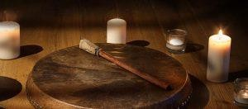
Upcoming Dates:
December 6th, 2025: Full Moon Ceremony Rhythm Instruments Welcome!
January 3rd, 2026: Full Moon Ceremony: Rhythm Instruments Welcome!

From Echoes of Myths
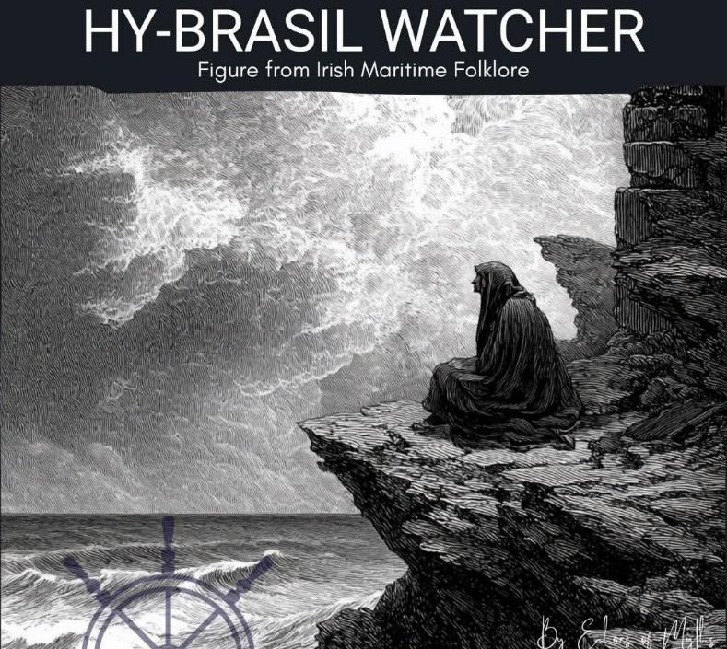
Hy-Brasil – The Vanishing Island of Irish
Legend 
Off the west coast of Ireland, beyond the reach of compass and sail, lies a place few have seen—but many have dreamed of.
It’s called Hy-Brasil—a mythical island shrouded in fog, said to appear only once every seven years.
Described in early maps from the 14th to 17th centuries, Hy-Brasil was marked as a real location—round, often split by a central river. Sailors searched for it. Scholars debated it. Stories grew around it.
According to Irish folklore, Hy-Brasil was not just a phantom island—it was a land of immense wisdom and healing, possibly home to an advanced civilization. Those who claimed to reach its shores returned with strange knowledge or visions they couldn’t explain.
 The Watcher of Hy-Brasil
Among the lesser-known tales is the figure of the Watcher—a hooded presence who appears when the island briefly reveals itself.
They do not speak. They do not move. They are simply there, gazing out over the ocean’s edge, as if waiting for something… or someone.
Some say the Watcher brings visions. Others believe they are a guardian of forbidden knowledge.
Then, as suddenly as the island came, both it and the Watcher vanish into mist once more.
️ Real or myth, map error or miracle—Hy-Brasil remains one of the most enduring mysteries of Irish maritime folklore.
Would you sail toward it, knowing you might never return?

This is Canada
Canada is the second largest country in the world. Canada is incredibly diverse and often looks nothing like people imagine it.


This isn't New Zealand. It's
Canada. (Chesterman Beach, British Columbia)

I asked the waiter, 'Is this milk fresh?' He said, 'Lady, three hours ago it was grass.'

-Phyllis Diller

From Over 100 Inspirational Quotes by Alan Chazen
Self-confidence is the result of knowing where you stand, knowing where you want to go, and knowing specifically how to get there.
Tidbits and Tickles:
I remember the words MOM always said to me… “What the heck is wrong with you?”

From A Guide for the Advanced Soul, by Susan Hayward
The fastest way to freedom is to feel your feelings.
-Gita Bellin

From Llewellyn's Witches' Calendar 2025
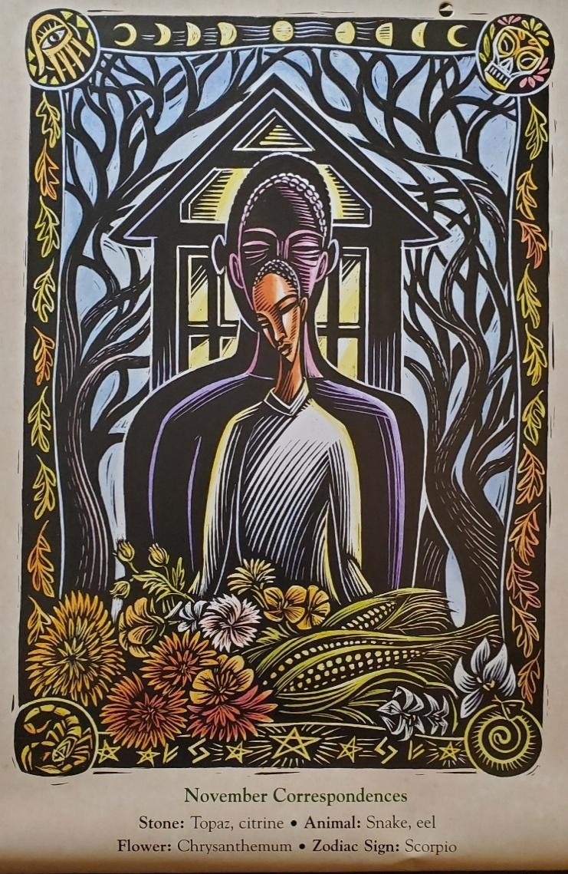
Early November marks a special season in central Mexico, when the rainy season is ending and the harvest of the Maiz (corn) is underway. At this time of the year, Dia de Muertos (the Day of the Dead) is celebrated on November 1 and 2. We honor our ancestors and dead loved ones and their lives, and we thank them for their blessing, as without it, our harvest would not have been possible. We gather with our family and friends and talk about our ancestors. We visit their graveyards. We set up ofrendas (offerings, altars) for them. We cook special meals and share our food with them by setting out plates for them.
During this time, we can take the opportunity to think, symbolically, of our harvest, of all that we have accomplished in the last year, of the projects that have been successful, of all the things in our lives that have prospered. And, at the same time, it is a great time for us to think of our ancestors, of those who came before us, and how their lives contributed
to what we have today and to our harvest.
We have a great variety of ancestors. We have ancestors of blood and chosen family, those who appear in our family tree. We also have ancestors of space, those who lived where we live and whose stories shaped the history of our land. And we have ancestors of spirit, those whose lives inspired or shaped our spiritual path.

A Gratitude Offering to Our Ancestors
First, think of your recent harvest, of what you are proud of, of your recent accomplishments. Think of the recent events of your life. Select on accomplishment that you would like to focus on that had an impact on you. For example, you got married or you earned a promotion.
Then, think of your ancestors (either of blood and chosen family, space, or spirit) and identify one to whom you feel more connected, someone whom you feel identified with, or someone whose actions, life story, or legacy has inspired you in some way. For example, it may be that you recently were able to accomplish a career goal that required you to be brave, and you feel identified with your grandmother, who was described as someone who had a lot of courage. Or, as another example, you were able to accomplish a spiritual goal, and you feel inspired by a spiritual elder of your tradition and their legacy.
Next, select a place or location that has meaning or that relates to your ancestor, such as their grave, the place where they used to live, or a place where you remember them. If this is not possible, select a special location at your home.
Finally, place an offering to them there. It does not have to be big but something that you find beautiful. It can be flowers, a stone, or a special meal. Present the offering by saying something like this:
I, (your name), in perfect love and perfect trust, offer this (offering) in your honor. Thank you for your (what your ancestor inspired), as it has contributed to making (your accomplishment) possible. Blessed be.
-Jaime Girones

Mudras
Taken from Mudras: Yoga in your HANDS by Gertrud Hirschi
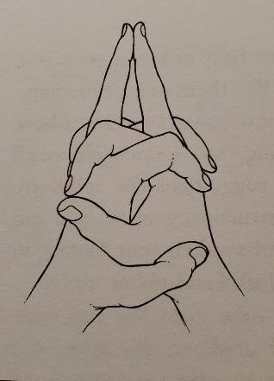
Matangi Mudra (God of inner harmony and royal rulership)
Fold your hands in front of your solar plexus (stomach area), point both middle fingers and place against each other. Direct your attention to the breath in the solar plexus or stomach area.
Do as needed, or three times a day.
This mudra strengthens the breathing impulse in the solar plexus and balances the energies in this area. It stimulates the wood element, which represents new beginnings, and the earth element, which gives life its
depth. The heart, stomach, liver, duodenum, gallbladder, spleen, pancreas, and kidneys profit from the Matangi Mudra. An excited heart becomes noticeably calmer, and inner tension (such as diverse spasms or sensations of fullness) that hamper digestion are resolved. According to Kim da Silva, this mudra also relieves vague pain and tension in the jaw.
Herbal Remedy: Lavender and verbena are herbs of repose and harmony.
Green and yellow are the colors of the solar plexus. Yellow lightens our mood and stimulates the mind. Green is the color of harmony. Each of us needs an inner place (a retreat) where we can go to be safe. We can create this place inside ourselves. If we can get there without using any physical means of transportation, we also don’t pollute our environment and can really save time.
Meditation: Imagine a yellow desert in which you create a beautiful green oasis, a place of harmony and joy. This is your personal retreat, and you form it completely according to your own preferences and needs. Here you find yourself again. You become calm and still, and your soul attains peace.
Affirmation: Rest, silence, and peace fill me completely.

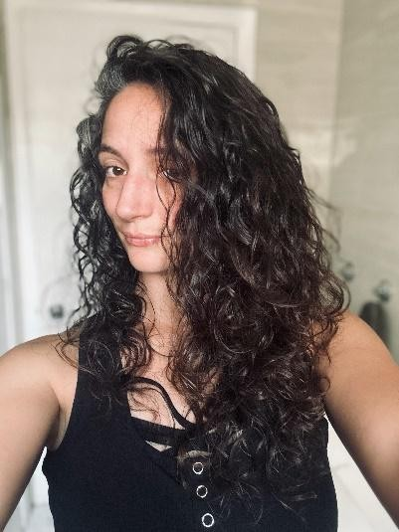
Marina’s Divination Station

By Marina Evans
Hello one and all and welcome back to the Divination Station!

All good things come to those who wait, and there certainly isn’t anything wrong with waiting. The problem with this aphorism is that some think that waiting is all that needs to be done. We can sit in our chairs and stare out our windows until what we want knocks on our doors and all we must do is open it. But what about those things that go racing down our road? What
about the stranger waving from the sidewalk? Do we ignore all those things that don’t knock? Sometimes the greatest opportunities are waiting beyond our doorstep and there is need for us to stand from our comfy armchairs and go out into the world for things to find us. We are all waiting and asking for a chance, but how many have we missed by thinking ‘That one wasn’t for me because it didn’t knock on my door’. To get the opportunities we want, we often have to take risks—a reminder from today's deck.

FLOWERS OF THE NIGHT ORACLE by Cheralyn Darcey

These cards caught my eye for the simple dark coloring and the theme itself. It’s one of the smaller decks with 44 cards and the art is quite simple. Splashes of color on a black background, reminiscent of the velvet poster we had as kids of the scratch away art papers that started all black until you chipped away at the bits of flour to reveal a contrast of color to find a picture. There is a certain charm in its simplicity. The cards themselves are a heavier stock with a high gloss finish, so they shuffle nicely and aren’t too slippery in the hand. The guidebook is a basic but thorough 105 pages giving a description of the featured flower, where it’s found, and a little lore about the plant, as well as a divinatory reflection on what this flower is bringing to our awareness in the moment.
For the simplicity of the artwork, this deck has quite a bit to teach to those who are willing to give it a try.

Drawing of the Card

CHANCE
Darwin’s Orchid

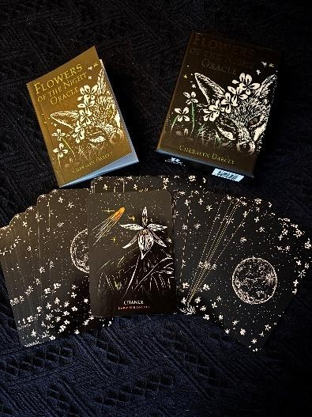
A beautiful white flower that blooms in Madagascar, Darwin’s Orchid seeks to remind us of the uncertain world of chance, and that sometimes, uncertainty is the way forward. Change is something inevitable that we all must face throughout our lives in many ways and at many times. Stability and structure are something we seek to make sure our lives are comfortable and safe, but change happens whether we want it to or not. While change can be frightening, sometimes it’s the push we need to get what we really want in life.
When things become too comfortable, we can begin to feel stagnant. And while that stagnation can make us long for more, the comfort we feel in our lives can be hard to risk. When we are too comfortable for too long, taking chances becomes harder and
can lead to complacency and make us lose sight of those dreams we have for ourselves. Darwin’s Orchid shows up to make us ask ourselves the hard questions; what are our dreams and goals worth to us? Certainly, there is risk involved in taking chances on things that are not guaranteed, but nothing changes if we don’t take a chance on that which is uncertain. Any move forward will inevitably change your scenery, and you will have to decide if the change is worth it, but nothing can happen if we don’t move from where we are.
This card brings a message of success but not ease. It tells us that if we keep ourselves open to opportunity, if we risk what we can and take those risks, it will be messy, but we will be rewarded for taking the step. We will reap the rewards for what we have sown, but we need to be open and willing to do the work. Stepping out the door will be hard but giving up on what we wanted for oneself because we were too afraid to take the chance will be harder in the end.

Find me on Instagram (@29crows) and share deck ideas you would like to explore if you enjoy this one.

Stop Chasing Peak Experiences

By Alecia Iwanchuk, Intentions Yoga
Chasing peak experiences causes chaos in your nervous system and will never lead to healing because there is too much energy to organize. What you are doing is taking a trip to Disney Land for your nervous system. Eventually the trip will end, and you will have to return to normal life. What goes up must come down.
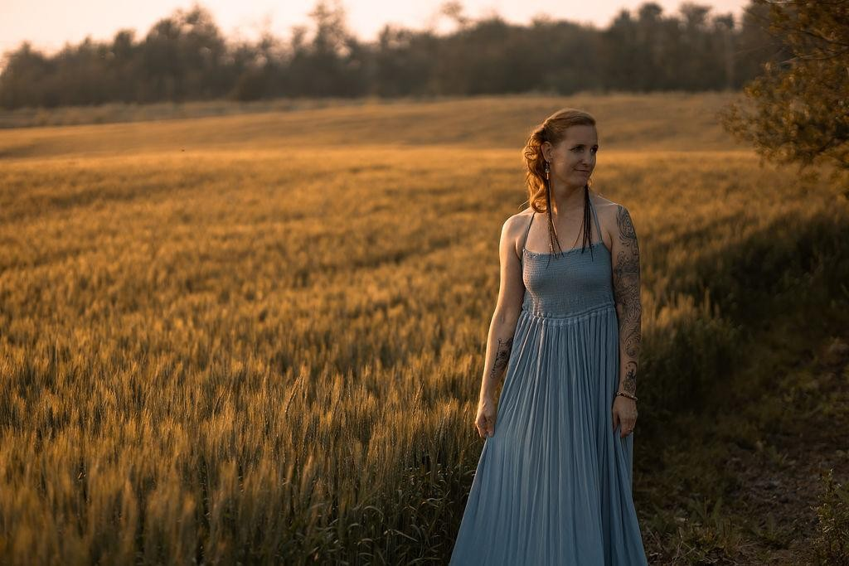
You are chasing, the next big release, the next big cry, the next big moment that skyrockets you out of your mundane everyday life. As an ex-drug addict, I have been extremely mindful when it comes to what I will do and use in the name of my “healing”.
I remember my first time attending a “new age” event, the man selling drugs called it “medicine” – I assure you this
was plain old MDMA as sure as the eyes can see. Words can be skewed, and intentions can get manipulated.
The cold hard truth that we all know deep down, is that real change is uncomfortable, its slow, it’s not flashy, it’s not instantaneous. Healing requires time to pass and integration to occur. Real change does not come from going to the retreat, but from the changes you apply to your life after having the experience. Real healing does not come from going to breath work and crying your lungs out but by integrating what you learned into your everyday life after being guided through the experience.
We are being sold healing now as entertainment. As an exciting quick fix solution and I assure you – it’s not that simple. We are not that simple.
We are incredibly complicated human beings. And healing requires a gentle uncovering of the layers of who we are. The more you uncover the deeper and more complex it becomes. This requires patience and persistence.
Yoga is different. Or rather, perhaps yoga was always just yoga. It has withstood the tests of time. I am not sure if you ever could overuse it because it requires you to have full control of all your faculties to do the practice. Your body will get tired before your mind. Sometimes, our mind drives us beyond our physical limits and causes dysregulation, even as we try to heal.
There is no disconnect during yoga. You have use of all your faculties and are fully aware of what you are doing. What your mind is doing and what your body is doing. There is full connection and awareness. Sometimes, but not too often there will be a noticeable emotional release. Tears and shaking that emerge spontaneously from deep within the body but not from an egos desire to manifest an “experience”.
The beauty and form that arises in the body from a dedicated practice of yoga is a mirror for the beauty and form that is shaping your mind and emotions internally. As within so without.
Yoga does not provide quick wins. It fosters discipline from the inside out. Your body will get stronger; your mind becomes clear and from this foundation the rest of your life organizes itself into coherence.
I am not writing this to discourage you from any of the current practices that are being offered, but to remind you that the real work is for you and you alone to do. The guides you meet along the way are there to help you – to point you in the right direction. The work that will ultimately change your life will come from the practical changes you make in your everyday life, not from any one practice or experience. The unglamorous things, the mundane decisions, the awareness practices, these are the things that, when done daily, will change your life.
If you are ready to have support in this journey, please check out my coaching programs at www.intentions-yoga.ca

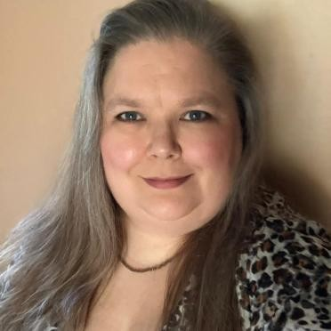
Rock Talk

SUNSTONE
I was surprised to realize in all these years I have not covered one of my favorite minerals Sunstone! It has such lovely flashy color, and when you take it out on a sunny day, the light dances across it. Truly a magical mineral! I find I like pairing it with moonstone for a balanced and complete energetic cycle. I often find myself reaching for the duo for group rituals where I am the acting priestess, wearing a bracelet of both together and
pendants of both layered one close to my heart and one my throat.
A member of the feldspar family, with only a Mohs hardness of 6- 6.5 it is not exactly a fragile mineral but can be prone to brittleness along the layers that make up feldspars. With shades ranging from flecks of reds, oranges, some yellow and even warm browns within a body of white to grey, most often opaque there have been more recent discoveries of clear gem quality variations.

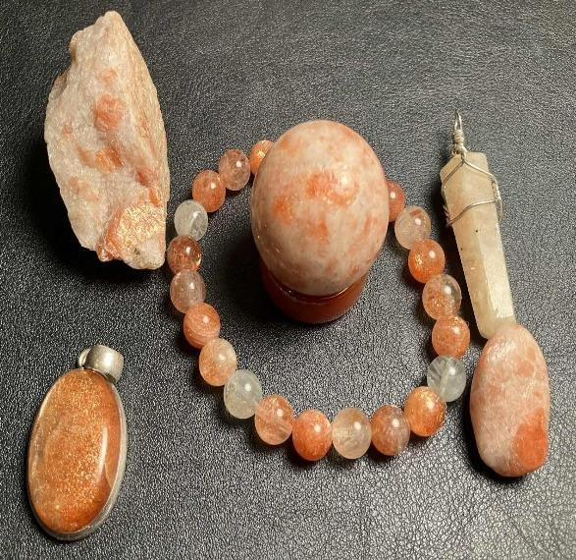
A key word for sunstone is personal power, if one struggles with feeling powerless, or has in their past given up their power; working with sunstone can help them reconnect and reclaim that power. Embodying Solar energy Sunstone can help by promoting openness and warmth, strength and benevolence, clarity within the mind and expanding consciousness, while facilitating the ability to share and help others find these characteristics within themselves. It can help one to overcome fears and insecurities that are holding them back, melting feelings of unworthiness, and self-doubt. Sunstone can be a powerful aid to those who are found in established leadership roles or help those who may
be newly undertaking leadership roles. Sunstone can also help one within that leadership role work from a place of responsibility and service to others, rather than a place of ego and self-glory. It can also shine light upon efforts and workings that are from a place of ego and dishonesty.
Sunstone can increase vitality and endurance.
Sunstone is believed to support learning and wisdom in academic pursuits.
This mineral does work well with the sacral as well as solar plexus chakra which can also make it a good support for creative projects. It can also bring heat, exuberance, innovation, and fire into relationships. Sunstone can be used to clear and energize the chakras as well, brightening and refreshing the flow and function of the system.
The solar connection of sunstone can help one associate with spirits, gods, and guides who are similarly connected to solar energies.
Physically Sunstone may be used to support treatments for sore throat, issues with the stomach, metabolism, digestion and ulcers. It can help promote recovery from cartilage damage often caused by sport, as well as those suffering from rheumatism, aching feet and spinal problems. (If one works on their feet all day sunstones may help ease the aches from that) Sunstone may also help support treatments to balance the endocrine systems, and treatments to reduce imbalanced hormones.

Paraphrased from “LOVE IS IN THE EARTH – A Kaleidoscope of Crystals by Melody” and
“THE BOOK OF STONES – Who They Are and What They Teach by Robert Simmons and
Naisha Ahsian. With personal add-ins and details by me (Ave)

Reflections from the Shaman's Hut

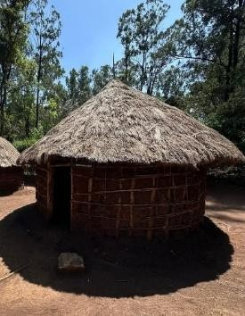
Day of the Dead By Trent Deerhorn
November 1st marks the Day of the Dead. This is a time to honor those who have walked this earth before us. It is about acknowledging our ancestors, those who are related by blood, those who are our chosen family, and those who are the ancestors of people we have never met. It is a time to allow ourselves to experience deep contemplation regarding all that we have which we would not have if it were not for our ancestors.
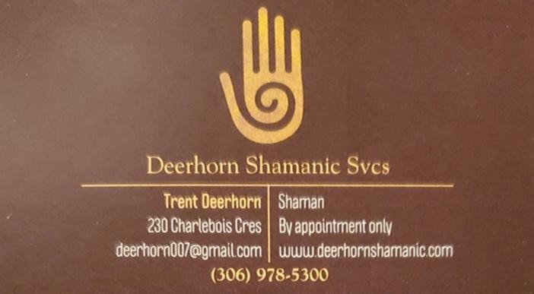
Things you can do to honor them include activities such as setting a plate of food for them at your dinner table, leaving a snack plate out for them (much like many do for Santa Clause), displaying photos of our ancestors in a prominent part of the home, and saying prayers to the ancestors in gratitude for their love and wisdom and sacrifices that they have made, or even creating your own ancestral altar.
But you do not have to do this ONLY on the Day of the Dead. You can do these things any day of the year if you choose to. If you would like to explore more ways of honoring ancestors, you can read about it in a lovely book titled Honoring your Ancestors: A Guide to Ancestral Veneration by Mallorie Vaudoise.

For more articles by Trent, check out his blog at www.deerhornshamanic.com.

A WITCH ALL YEAR LONG

By Ave Riddler

Over the years I have been approached to do interviews about being a witch. I have been open and public about my faith between Toon Town’s Pagan Summer Fest, and the years of the CWAS Saskatoon temple. It would have been impossible for me not to be so candid and as a result I have been more than willing to field these requests. Some have been remarkably well done, only once was the result dark or negative. These interview requests almost always come up in October, close to the 31^{st,} when witches are suddenly trendy. Some have been done by phone, through video, recorded and even a short video clip on global. My goal is always to try making witches less scary, less threatening, dispelling the misconception that we are evil, or worshiping a devil. I know so many on this path who are for various reasons private and keep their faith almost a secret, some who can’t even tell their nearest and dearest what they believe. I know I am blessed that in my journey my family and friends have never once cut me out of their lives for my practice. I have had some very intense discussions, but the results are always at least peaceful and respectful. Even more special is that both my parents are in fact proud of their daughter the witch; neither of them is on the path. My hope is that maybe a well put together interview, or news piece might help even just one person understand we are not what you see on TV or read about in books.

The reason this topic is fresh in my mind as I write for this month is I very recently was part of another interview. This time the person doing it knew some basics about my faith, and I wasn’t faced with needing to answer the same questions I often hear. It was delightful and refreshing to be able to discuss other aspects, explain we are more than just Halloween witches, and that there is more than one way of being a witch. That yes there are some who may use their practice for causing harm but that exists in every religion. Also, for the first time the interview was done within my home, where I live my practice and honor my path daily. My home is my sacred space, my sanctuary, a place where mundane and wonder mingle and blend. Within my home, everywhere one looks there are sparks of magic; an altar, a symbol of warding, right beside the kitchen stove, or beside the TV, nothing is tucked away in a closet. Because I am drawn to yellow, sunlight, and colors my home is bright and vibrant, which she found surprising and not at all what she had anticipated. There were moments of genuine laughter, moments of surprise, talk about the other sacred days of the year, talk about possible follow-ups over the year. I feel she truly reached a new level of understanding, and I fully believe once the results are ready for publication it will be a lovely and positive piece. I was glad to open my door to her, to share what it really is for at least THIS witch every day of her life. Yes, it will be posted and shared before October 31st because that is timely for the media, but she learned for many of us every day is special.

According to the Farmer’s Almanac 2025:
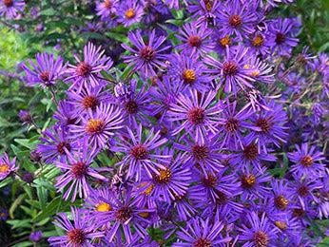
The differences between New England aster and New York aster are not obvious. The two native species are both hardy in Zones 4 to 8 and late in the season produce daisy-like flowers (commonly purple) with yellow disc florets. Still, there are subtle distinctions. New England aster is often bushier and taller – 3 to 6 feel tall compared to New York aster’s 1 to 3 feet. Its leaves are hairy, whereas New York aster leaves are smooth. Also, New England aster tends to have more ray flowers and thicker
stems. The New York aster typically blooms later in the autumn season.


November 2nd: Daylight Saving Time ends at 2:00 A.M.


November 5th: Full Beaver Moon


November 11th: Veterans Day/Remembrance Day (Canada)


November 20th: National Child Day (Canada)

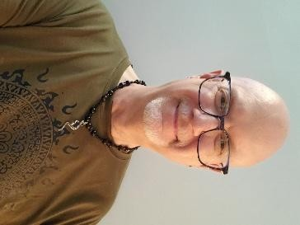
Ask the Shaman: With Trent Deerhorn
There were no questions sent in for this month, so I decided to answer a question that was posed to me years ago by a young boy in my family. He asked me why I thought that Remembrance Day was so important? His mother, being a pacifist, felt that it was nothing more than a glorification of a military mentality, which led to war and murder.
Although there is a part of me that is aware of that aspect of the military
lifestyle, there is a larger part of me that is grateful, from the deepest part of my heart, for the sacrifices that the men and women in the military have made to ensure that our country is safe for everyone. It does not matter what age they were, or what race they were. If they fought against fascism, they did their job. And because they did their job, I can live in a country where I am not persecuted for what I do (the burning times are still happening in other parts of the world) or for whom I love. Yes, we have a long way to go, but it was not that long ago that neither of those benefits would have been true. Because it is true now it means that, with time, other things will also be true that are a direct result of the sacrifices that the men and women of our military have made so that those things can become true. We have so many freedoms here. Those freedoms could easily be taken away with the wrong leadership, as is evidenced south of the 49th parallel. So, yes, I am grateful. Do I attend public ceremonies? No. I choose to honor them privately. I light a candle and send a prayer of gratitude to them…all of them. That is how I roll. But, more importantly, that is why I roll the way I do. Also, the mere fact that some folks can voice their opinions regarding the negative aspects of the military is further evidence that the military has done its job in protecting our right to have a voice at all.

Silver Years
When I was a kid, I wanted to be older. This is not what I expected.

Forum

We like your feedback! Of the previous issue
William Wrote: I enjoyed learning a bit more about Pan.
Jenny Wrote: Those Mudras really do work!
Cynthia Wrote: I have the Fallen Angel Oracle deck. It totally rocks!
James Wrote: I loved the article on Sacred Discernment. Well done!
Max Wrote: I have never heard of hypersthene before. How fascinating!
John Wrote: I do not know how I would handle it if I were aware of spirits around me 24/7!

Classified Ads

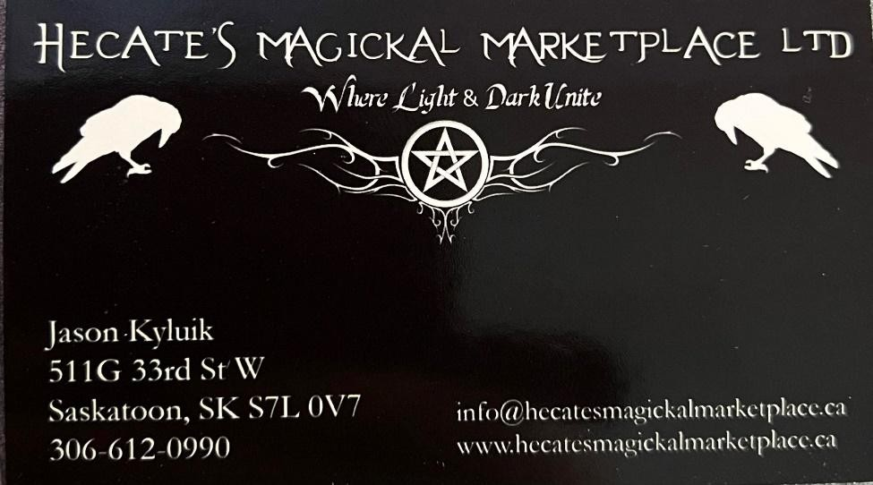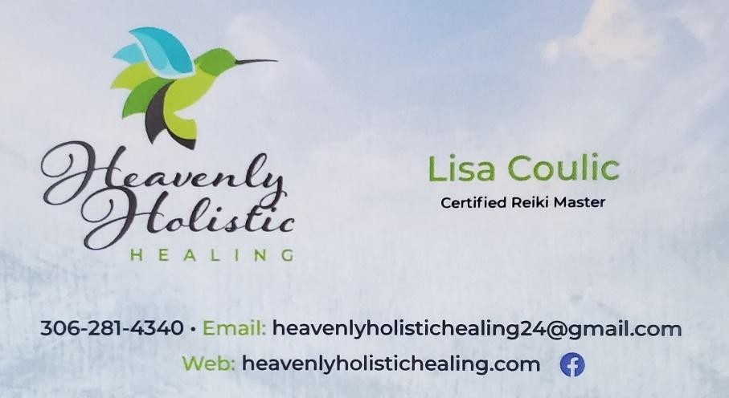

Video Chat with the SHAMAN!
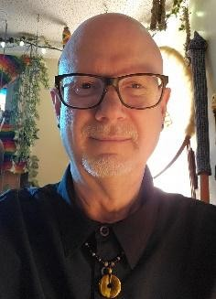
As part of my Shamanic Practice I have, for years, provided long-distance healing work for people. This sometimes comes as an energy treatment and sometimes as a telephone counselling session. Well, now there is even another option available! We can now have sessions on Face Teams, or Telegram, and you can speak to me face to face! If you are interested in this option, simply email me at deerhorn007@gmail.com or phone me at (306) 978.5300 to book an appointment. Blessed Be!




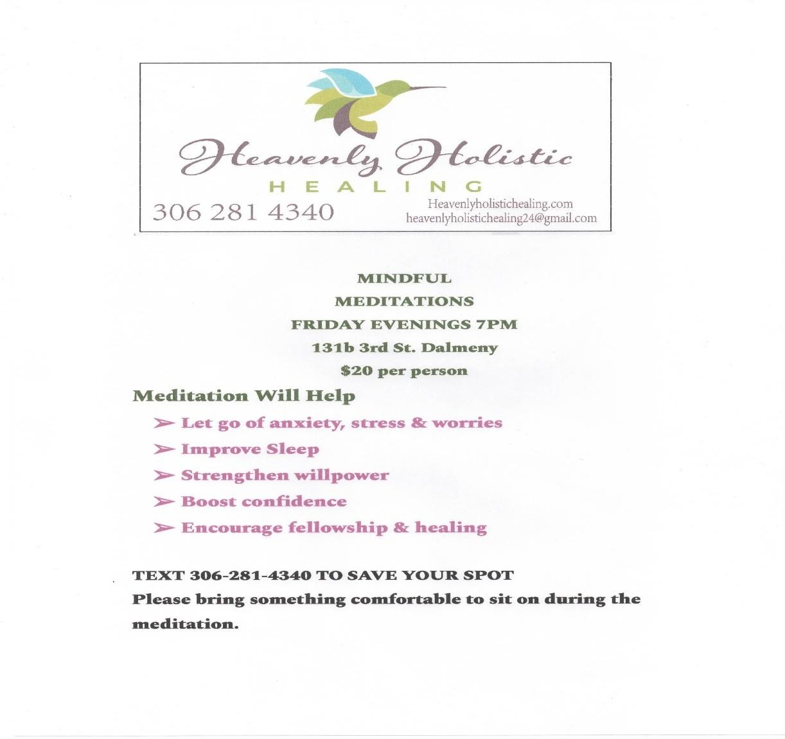

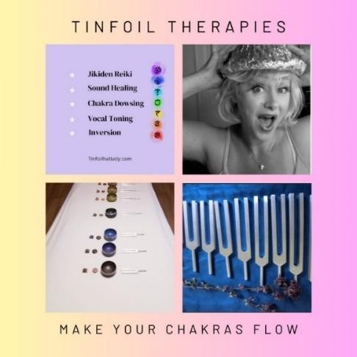

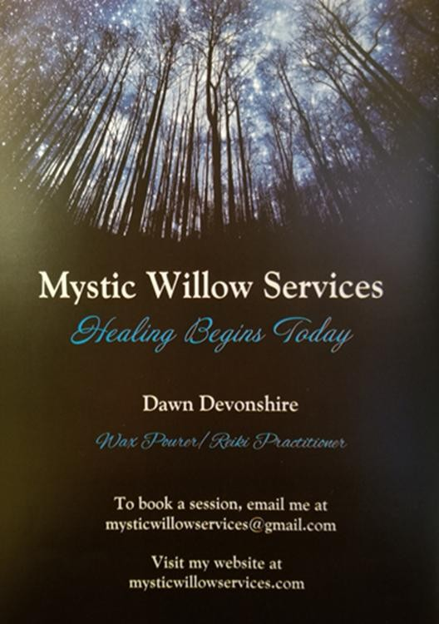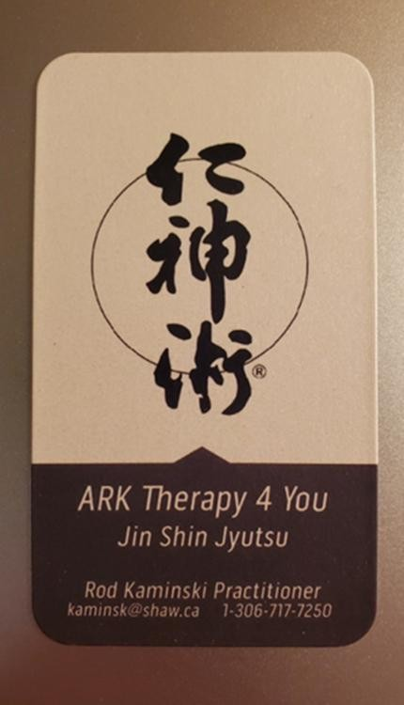

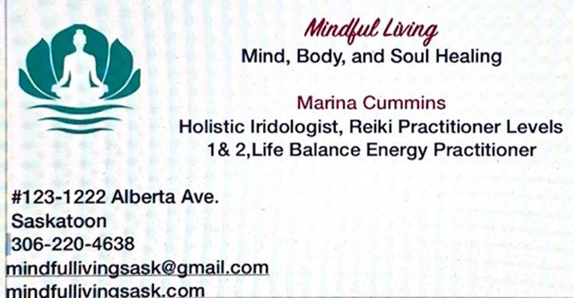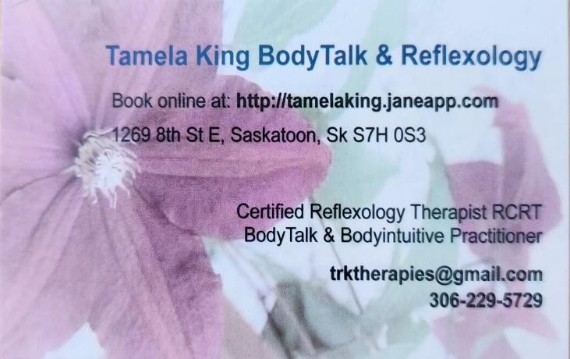



Flight Newsletter Advertising
All ads must be in by 6pm on the 20th of the month PRIOR to the issue that the ad is to be placed in. No exceptions. Send to deerhorn007@gmail.com.
Classified Ads:
FREE for article contributors
$45 for business card size $55 for half page.
$70 for full page
Events: FREE for Non-profit organizations and Article Contributors
$25 for Profit organizations
Workshops/Classes

$40 half page$50 full page

