Flight: A Living, Breathing Document of Consciousness
Volume 8 Issue 82, April, 2019

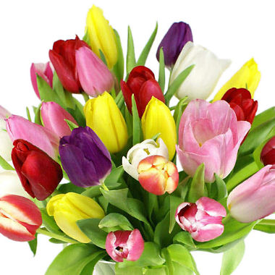

Articles and excerpts that will inform and inspire!

A Letter from the Editor:

Alas! Spring is here! This winter was very difficult for me. The cold weather extremes that we had really wore me down. I am so HAPPY that I am now able to break out my collection of Hawaiian shirts and put them to use! The snow is almost all gone and soon it will be time for planting seeds.
Have you ever wondered about the landscape of the heart? We have a poem submission that speaks to this. And have you ever wondered about tourmalinated quartz? Ave shares her wonderful insights on this dynamic crystal. And for those who are looking for a new pet, check out our pet rescue section!
Check out as well our upcoming events page. There is a lot going on in our community and there is always a fascinating event that one can attend.
Thank you to all of my wonderful contributors! This newsletter is so much better as a result of your participation!
Please feel free to forward this on to whomever may be interested. And if you are reading this for the first time and would like to receive your monthly subscription free, please do email a request for that to me at deerhorn007@gmail.com and we will make that happen!

Enjoy the read!
Trent Deerhorn
Editor

Deerhorn Shamanic Services Floating Drum Circle
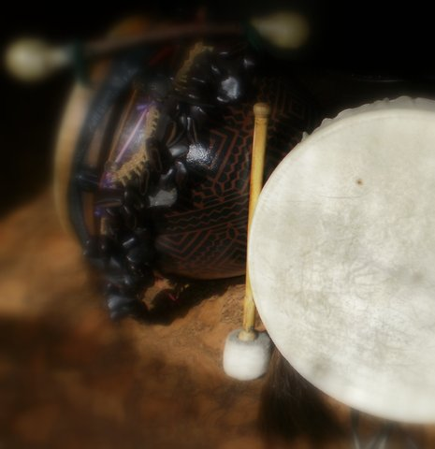
The Floating Drum Circle will now be available!
What is a Floating Drum Circle? It is a Drum Circle that is able to move from one location to another.
How does this work? Invite a minimum of 10 friends over for a drum circle in the privacy of your own home. Trent brings the supplies for the Drum Circle and the Ceremony.
Ceremony? Yes. As you all know, Trent's Drum Circles are Ceremony/Ritual based, which makes them both spectacular and unique. These celebrations can be in accordance to the phase of the Moon, or the Season, or whatever you choose to celebrate.
Who is in charge? You are in charge of the space and the people you invite and the number of people you can comfortably accommodate. Trent is in charge of the circle once it begins.
What if I don't have 10 people? It is important to have the minimum of 10 in order to be financially feasible for Trent to lead the circle. Upon your request in advance of the registration date, Trent can share the date and time and contact number with his contacts who can then contact you to see if there is enough space.
Who pays? Each person pays their fee ($20) ahead of the date of the Drum Circle. If the fee is not paid 3 days in advance of the circle, the spot goes to the next person in line on the waiting list. The host/hostess collects all fees and pays Trent before the circle begins on the date set. Hosts/Hostesses get the Drum Circle free of charge.
Children in attendance must be strictly monitored by their parents.
Any damaged supplies must be paid for or replaced by the one who damaged it (or parents if it is a child) by a similar article of equal or greater value.
What is the method of payment? Cash only. This makes it much easier for the host/hostess to collect.
To arrange for a Floating Drum Circle in your home, please contact Trent Deerhorn at deerhorn007@gmail.com or at (306) 978-5300.

Upcoming Events

The Information Highway
Join Beata Van Berkom of Tinfoil Therapies and Trent Deerhorn of Deerhorn Shamanic Services, for a Dynamic Workshop in personal growth and development. Through shamanic journeying and discovering the information path through the chakra system, you will learn about your personal sovereignty, sacred responsibility and how to generate your own personal happiness no matter what is going on in the outside world. Become aware of what it is like to live within your Sovereign Temple inhabiting your Sacred Self.
Date: Saturday, May 18th, 2019
Time: 10:00 am - 4:00 pm
Early Bird Tuition: $80 if registered before April 18th, 2019
Tuition: $120 after April 18th
Location: Oshun House, 912 Idylwyld Drive N, Saskatoon, Sk
Bring your own box lunch!
Registration Deadline: May 4th, 2019
Contact: Beata at tinfoilhatlady@gmail.com or text to (306) 291-4706

CONGREGATIONALIST WICCAN
ASSOCIATION OF SASKATCHEWAN
SKY RIVER TEMPLE
BELTAIN
Public Ritual
April 28
2:30
Gabriel Dumont Park
Saskatoon Sk.
Potluck social to follow
(No nuts/legumes/seeds/soy)
FREE to attend
DONATIONS welcome

Next ritual will be
June 16
2:30
Gabriel Dumont Park
Saskatoon Sk.

RITES BY THE WATER
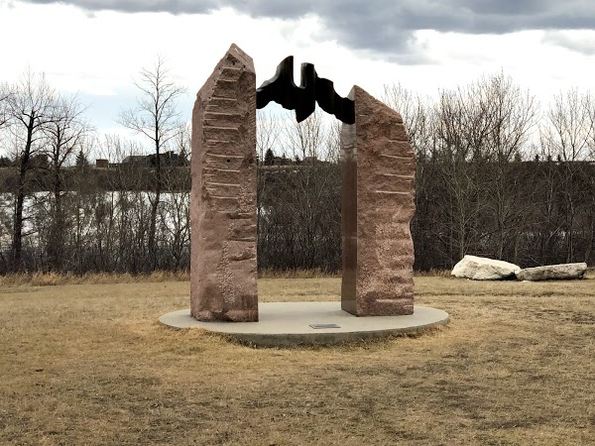
This is a monthly celebration to give thanks to the Gods and the Goddesses, to get together once a month in Public Ritual. These are outdoor events and people should dress for the Weather. All we ask is that all that attend to so with an open heart and an open mind. As Pagans we do not discriminate against anyone so we ask the same of those who attend. These Events are free.. free for all who attend, free for all who are interested in a monthly open circle, free of all Prejudice. Blessed Be.
This month's Rite will be to celebrate the planting of the seeds. We shall continue with the revitalization of ourselves and preparing for our personal growth. . The next event is on Sunday April 7th at 1 pm, it will be held at 2703 Spadina Cres. East Saskatoon Sask.

TOON TOWN’S PAGAN SUMMER FEST.
Friday June 21 to Sunday June 23 2019
WELCOME TO THE SEVENTEENTH YEAR OF FESTIVE FUN!
This is an all-inclusive three day, two night camp-out festival, in the Saskatoon area.
Included are meals, crafts, guest speakers, drum circles, circle dancing, rituals, and MORE!
Tickets on sale starting April 1, with different early bird price rates
LIMITED TICKETS AVAILABLE!
All available rates are listed below until we are sold out!
APRIL 1 - 30
$70.00 Adult
$55.00 Child (12 & under)
Group Rate offer for 4+ people
$10.00 off each ticket.
MAY 1 - 31
$80.00 Adult
$65.00 Child
Group Rate as above
JUNE 1 - 12
$100.00 Adult
$80.00 Child
No Group Rate
Contact Ave Riddler at
Phone (306) 329-4719
Email toontownspagansummerfest@gmail.com
Website http://toontownspagansummerfest.yolasite.com
We are partially sponsored by the folks from the wonderful home of our event Ancient Spirals! http://www.ancientspirals.com/

From Llewellyn's Witch's Calendar:
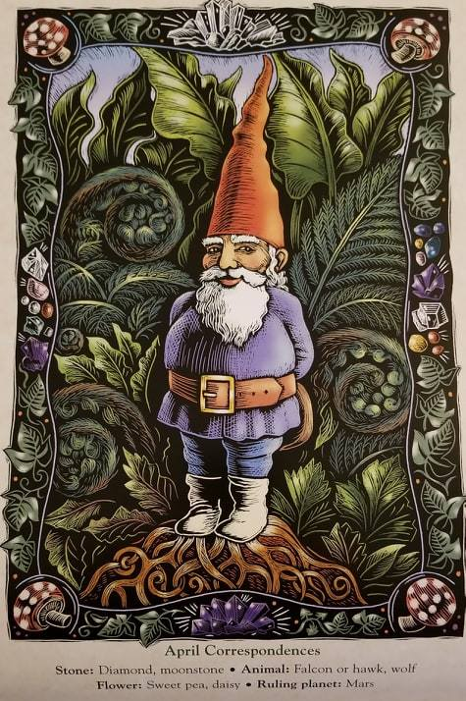
April
When folks turn their minds to gardening this month, some curious creatures often make their first appearance of the year...Cheerful, cheeky, and endearingly kitschy, gnomes - the clay, resin, and plastic varieties - have graced gardens since the early nineteenth century. Never mere decorations, garden gnomes have always served a magical purpose. As manifestations of the element of earth, they're directly connected to the abundance, prosperity, and fertility of the physical realm. Of all the elemental spirits, they're the most like us, as we are both tied to this planet.
In the past, gnomes were placed in gardens and barns as good luck charms and protective talismans. Indeed, they were often set to watch over buried treasure - the only means some people had to protect their wealth. Today, gnomes both male and female appear dressed in traditional pointed hats (good for burrowing in the earth!) and sometimes in leather jackets or holding fishing poles. You see, garden gnomes reflect the people to whom they belong, for they are familial as well as elemental spirits.
No home is complete without a garden gnome, whether he sits in a sprawling lawn or in a flower pot on a fire escape, but it's important to remember a few rules when working with gnomes. When neglected, these spirits tend to be mischievous, encouraging plants and animals to be unruly and untidy to get your attention. Be sure to:
1. Move them. Gnomes like to explore and have been known to move themselves if you don't help them. Place them in different parts of the garden, perhaps to mark the change of season.
2. Give them presents. Gnomes are especially fond of all things earthy: stones, crystals, and things that grow. A mushroom on which to perch would be a welcome treat.
3. Don't stop at one! Gnomes love company. Place new arrivals far enough apart that each has his or her own territory but close enough for conversation.
4. Keep them spiffy. A fresh coat of paint when needed and perhaps some jewels or crystals for their hat or coat (applied with a hot glue gun) will make them shine and better able to draw good fortune to your door.

Garden Guardian Ritual and Blessing
How do you know if a gnome is right for you? If his expression makes you smile, you've found him! Welcome your gnome into your family by finding out where he'd like to roost. Walk around your yard or garden with him and listen - he'll let you know where he'd like to be. Generally, gnomes don't want to be exposed; legends suggest that they, like their troll cousins, turn to stone in direct sunlight. Being hidden in plain sight is more to their liking, sheltering under a tree, peeking out from behind a bush, or nestled in a bed of ivy. Once you've settled on a spot, say his name and this incantation:
Wherever you are, wherever you roam,
Bless our hearth, protect our home!
My house is yours, and yours is mine,
Your spirit and my life are forever entwined.
Set your gnome in his new space along with a traditional gift of porridge (well buttered) and something of the earth: a crystal, seeds (to plant, if the weather allows, or as a treat for animal friends), or a bit of salt (ever practical, gnomes are the original "salt of the earth").
-Natalie Zaman

Things to Know

Your job won't take care of you when you are sick. Your friends will. So stay in touch.

Rock Talk by Ave Riddler
Tourmalinated Quartz
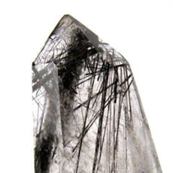
This happens when tourmaline crystals form within the body of the quartz. This combo carries the aspects of the quartz, as well as the aspects of the tourmaline. Tourmaline quartz can be found in most members of the quartz family, most commonly the clear or smokey. The types of tourmaline can be any color; most commonly black tourmaline. Each variation will slightly change the overall energy of the crystal. The following information is more of a generalization based on clear quartz with black tourmaline; most books don’t dig too deeply into the properties of the combinations of Tourmalinated quartz because there is so many that can occur.
Tourmalinated quartz can help produce an atmosphere soothing energy, taking the edge off of destructive energies in a space. It can also help adjust imbalances within its environment, in the space of the person using it. This energy can be directed within to assist in discovering one's innate strength to mitigate hostile situations. The other side of this energy is it can leave the environment or person that has received this energy in a cleared and unpolluted state. One cautionary note, because Tourmalinated quartz acts as a sort of energetic vacuum, they do require more frequent clearings and cleansing to remain healthy.
This clearing energy can directed into the mind to help provide clear thinking, and focus while helping to remove negative and destructive self talk. This can also be useful when battling addictions, helping to promote any steps that are being taken to move beyond the addictions.
This combination of Tourmalinated quartz can help connect you to the full spectrum of electromagnetic energy all around you; often an imbalance happens because we focus too completely on one kind of energy more than another accidentally blocking out the rest of the energies. The black Tourmalinated quartz can help create balance by connecting and integrate with all those energies. The combined energy helps unite the energies of higher frequencies with the lower and more physical, promoting a more holistic vibration.
Physically tourmalinated quartz can help strengthen the body, release toxins, purify the body, and help improve eating habits.
Paraphrased from “LOVE IS IN THE EARTH – A Kaleidoscope Of Crystals by Melody” and “THE BOOK OF STONES – Who They Are And What They Teach by Robert Simmons and Naisha Ahsian. With personal add- ins and details by myself (Ave)

Teacher and Kid
Teacher: Clyde, your composition on "My Dog" is exactly the same as your brother's. Did you copy his?
Clyde: No, sir; It's the same dog.

Indian Hills Community Center, Colorado signs
Forget world peace. Visualise using your turn signal!

Local Photographers
Here are photos of two lizards I saw when we were in Florida. I don't know what kind they are, but they are small, move like lightning, and are plentiful.
There are also two photos of an alligator I saw. I think this one was maybe 5 feet long at the most. Just a little one.

The Landscape of The Heart
by Gail Fulkerson

Dig, because your life depends upon it.
Dig beyond your endurance, past the bloodied fingers and swollen eyes;
past the aching, spent muscles and screaming joints, past the sound of your heart pounding blood through your veins.

You are weary beyond measure but it matters not.
Wipe your face with a filthy rag as you rasp another breath
into lungs coated with the stench of toxic air.
Stab the shovel deep; you are clearing a path through the detritus of losses
framed in hopelessness,
memories cobwebbed one to another with unacknowledged grief.

Find the door you placed there so long ago, when the landscape was pristine,
and the portal easily found, your means of escape from an ever lurking snare you knew
would find form in your future.

New life pulses beneath your feet.
The door lifts rhythmically as it breathes.

Speak the incantation that dissolves the chains and watch the dust of eternities rise upon the new light as it streams urgently, unabated through the cracks around the door.
The sound of decaying iron hinges screeching and howling as they stretch beyond their comfort is almost too much to bear.

Keep pulling steadily upon the rotted metal ring and do not let go!
As strong as ancient hinges think they are, you are stronger, so pull!

Now is not the time to say you cannot do this, that you do not have the strength.
Tighten your grip and refuse to allow palms slick with blood and sweat to let go.

Put your back into it and open the door. Pull with all your might!

The sweat of your brow, each drop a testament to the labours that brought you here,
finally, to the brink of your success.
Giving up now would negate all your efforts.
Turning your back on yourself is the deepest cut of all, the final killing blow.
There may be no coming back if you allow it.

Feel your eyes welling with emotion.
The tears that blurred your vision will finally be shed.
Let them slide freely down your grimy cheeks;
smear them away with the back of your sooted hand.
More will follow and they need a clear path.

Unspoken words wad up in your throat, demanding their freedom.
Choking them back is futile. They will only choke you back.

The landscape of your heart, littered with broken dreams and ruined lives, needs clearing, but before you begin, answer one question:
When did your heart become a dumping ground?

The pathway is clear, the dust settled, and the old door is wide open.
When you are ready, step across the threshold,
tossing a ball of cleansing light over your shoulder as you go.
Remember to latch the door behind you.

New life and light prevail - always.

Thought for the Day:
How much longer will you go on letting your energy sleep?
How much longer are you going to stay oblivious of the immensity of yourself?
Don't lose time in conflict; lose no time in doubt - time can never be recovered and if you miss an opportunity it may take many lives before another comes your way again.
Bhagwan Shree Rajneesh - A Cup of Tea

Extremes in Our World that You should Know:
Which country is the most bicycle friendly in the world?
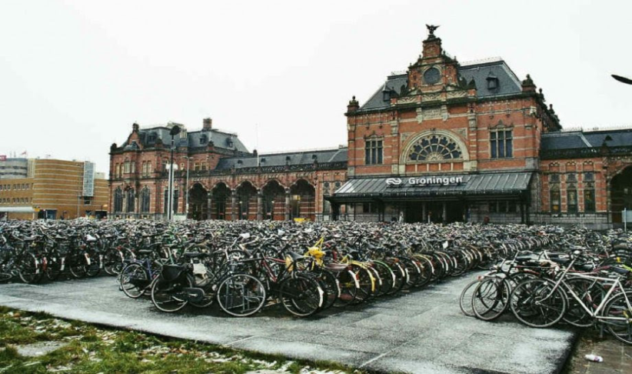
The Netherlands …
By comparing cities using the average number of bicycle trips made daily, one city reigns supreme:
Groningen in the Netherlands. About 50 percent of the population commute via bike daily, making it the city with the greatest proportion of cyclists.
However, many other cities in the Netherlands have a great bicycling tradition.
Paraprosdokians:
Going to church doesn't make you a Christian, any more than standing in a garage makes you a car.

From 365 Zen daily readings by Jean Smith
If you want to be free, get to know your real self. It has no form, no appearance, no root, no basis, no abode, but is lively and buoyant. It responds with versatile facility, but its function cannot be located. Therefore when you look for it you become further from it, when you seek it you turn away from it all the more.
-Zen Master Linji (Rinzai, D. CA. 866), in Zen Essence

Reflections from the Shaman's Hut
Vulnerability and Strength
In our culture, and by that I mean the Western culture, vulnerability is seen as a weakness. It is likely that way in other cultures as well. I have known many from diverse backgrounds and the story seems to be the same. But because I cannot speak to someone else's culture, I will speak to only my own. And when I say that I will speak to it, that means that I will point out MANY of the plethora of problematic attitudes within it.
In Western culture people are expected to just "buck up" when it comes to things that have harmed them. Often the victim is seen as the problem, not the perpetrator of whatever the toxic attack had been. This is messed up. Quite often males are raised in a way that promotes that "cowboy" attitude toward their feelings, as though having feelings will make them less of a man. And it is not just men that program boys to shut off their feelings. Their own mothers often do this. And then their girlfriends and wives will do it. In Western culture women are hard wired to find macho men to be with (thinking it will provide some form of physical safety), so when they find their husbands tearing up at a touching story or experience, they belittle their husband for being too soft. I know, not all women do this. But there is a great amount of toxic femininity in our Western culture and there is no getting away from that fact. So boys are told that their feelings either don't count or that they should not even exist.
Then feelings get stuffed away into a deep, dark hole in the male psyche. Until they cannot be stuffed anymore. And so at a moment when one least expects it, BAM! Those feelings all come flooding out in a combination of self-loathing, fear, rage and grief. And then everyone tends to label that as "toxic masculinity".
If boys in our Western culture were raised and nurtured to become nurturing, this nonsense would not be taking place. People do not have to lose their minds just because a boy likes to play dolls with his little girlfriends, or even just by himself. They do not need to feel affronted by the fact that sometimes he likes to wear bling or even wear more feminine clothes. When boys and men connect with their inner feminine energies what they are doing is connecting with their empathic selves, with their nurturing selves, and with their creative selves. All the social stigma about what is "gender appropriate" behaviour or attire is absolute bunk.
The truth of the matter is that with vulnerability comes great strength. When we are strong enough to allow ourselves to be vulnerable we tell the world that, "Hey! It is okay to be vulnerable with me!" And when we allow ourselves to do this frequently we discover that others become inspired and actually think of us as strong and confident as opposed to weak and a "push over." There is great release of toxic energies when one, for example, cries. Yes, one can feel exhausted after a good cry session, but at the same time all that toxic buildup gets to just "let go" and we feel lighter and stronger as a result.
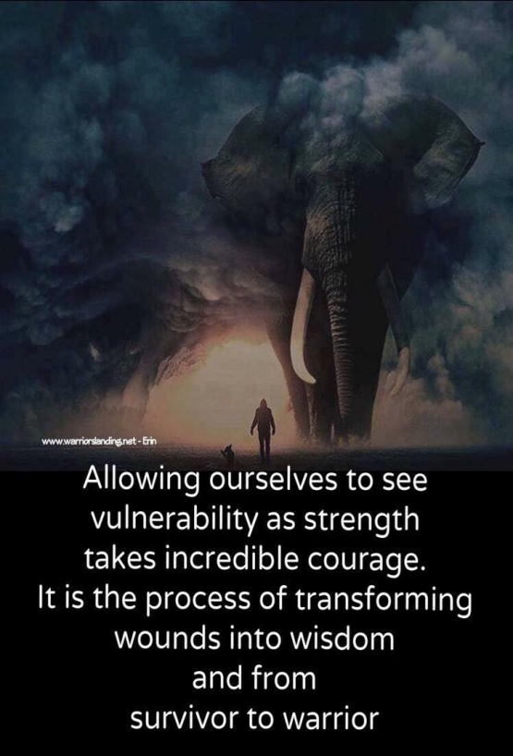
True warriors are the ones who can let their emotions be expressed. And that brings a calm and steady feeling to those around. There is nothing scarier than being in the presence of a person who holds all emotions in. You just never know what it is that is going to come blasting out and what damage will be done in the process. But when you are with a man who is able to laugh, cry, express himself romantically as well as when he is angry about something, or frightened, or insecure, you are in the presence of a true warrior! This is a man who will make 10,586 peanut butter and jelly sandwiches for his children as they go off to school. This is a man who will become sleep deprived as he takes on night duty with his children while also holding down a job. This is a man who will dodge into oncoming fire when someone is firing at his kids. This is a man who is PRESENT AND ACCOUNTED FOR throughout life! This is a WARRIOR. The more that people encounter this concept and begin to adopt it and honour their men for being present and accounted for, the faster our Western culture will develop into a truly peaceful place.
But do not confuse this with a man who is simply his wife's pawn. That is something else entirely. That is a man who does not know himself enough to actually have and hold an opinion of his own beyond what his wife tells him it should be. There are way too many men like that in our world. And as a result we have all sorts of drama crop up that need not be there. We also will see these men ditch their male friends because their girlfriend or wife doesn't like them (mostly because she cannot control or manipulate his friends). I have seen men ditch their own brothers and fathers because some woman they are with can't control or manipulate those people in his life so she drives a wedge between him and his own family. She does not care about the fact that men need other men in their lives for moral support. She does not care that she is isolating him from all of his moral support (one of the first signs of an abuser). This type of toxic femininity has got to be called out and it has to stop. And she would not be able to do that if he were strong enough to stand up to her. This is the making of a highly toxic relationship and, guess what, it is the MAN who is being abused there.
It does not matter if a man is straight, gay, bi, trans or whatever else. Those are just aspects of the self that are really nobody's business. The fact is that all men in Western culture suffer from the toxic attitudes toward masculinity and what makes men...well...men. Those attitudes come just as much from women as they do from other men. It is time to stop this toxic cycle of abuse. It is time that men are allowed the space and air time for their emotions and to express what their actual needs are so that they can be met. The world will, indeed, be a much happier place if everyone could just communicate and not be belittled as a result.
For more articles from the Shaman's Hut, visit Trent's blog at www.deerhornshamanic.com

Encouragements for Personal Development:
Taken from Meditations with James Van Praagh
Any form of self-condemnation is unnatural to the soul. Guilt especially creates disharmony and causes ailments and illness in our physical bodies.

According to the Farmer’s Almanac 2019:

Build-A-Bog
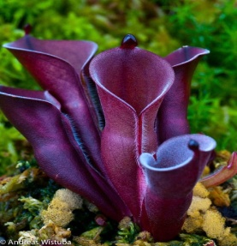
Thriving in zones 5 to 10, container bog gardens support unusual selections such as purple pitcher plant, round-leaf sundew, and common butterwort. To create a mini-bog, place a wide, shallow container in a spot that receives at least 5 yours of sunlight. Cover the bottom third with pea gravel and fill the remainder with a mix of one part sand and two parts peat moss; saturate the medium with distilled water. Let it sit for 1-4 weeks until the pH is balanced, adding more water as needed to keep the mix moist. Pop in the plants after having washed their roots thoroughly. Keep the garden consistently wet.

April 5th: New Moon:
To encourage new growth, prune shrubs and trees between the new and full Moons.
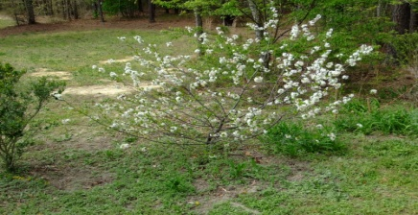

April 19th: Good Friday/Full Pink Moon
Scatter seeds of annual poppies in the garden while the weather is still cool.
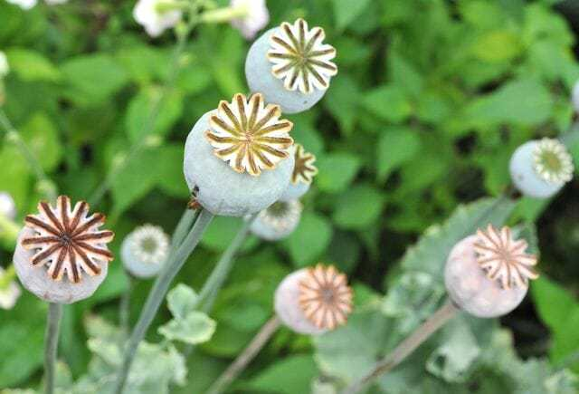

April 22nd: Earth Day
Nature always wears the colors of the spirit. - Ralph Waldo Emerson, American poet (1803-82)
April 26th: National Arbor Day
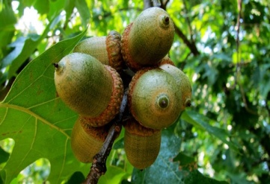
The oak - America's national tree - begins to produce acorns 20 years (most common) to 50 years after germination.

Puppy Smiles

Ask the Shaman: With Trent Deerhorn
Q: I recently found a spell book that has a spell in it that will theoretically allow me to make someone fall in love with me. Before I do this spell, I thought I should ask someone like yourself if this is a good thing to do?
A: There is a reason that you hesitated. It is because innately you know that this is not advisable. Let me put it to you this way. You are at a bar. Some dude sees you and decides he is going to have you, regardless of whether or not you consent. He slips a Roofie into your drink. You wake up the next day completely out of it and realizing that you have been sexually used and abused by someone. It doesn't matter if you knew the person or not. You were just sexually assaulted. It doesn't matter if you initially liked him. You were sexually assaulted. It doesn't matter what you were wearing. You were sexually assaulted. It doesn't matter whether or not he thought you liked it. You were sexually assaulted.
Now...replace that word "roofie" with the word "spell." Replace "him" with "her" or whatever gender it may be. The story is identical. You are now the perpetrator.
And when you think about it. Would you really want to have someone who only had romantic feelings for you because of some spell that was cast upon them? Or would you rather have someone who loves you because they have come to know you and appreciate all the human aspects of who you are? Some feel that doing a spell like that would be like casting a stone into a pond. All the karmic ripples would find their way back to you, sitting on the shore.
But let me tell you something cool about love magic. It works best when the focus in on yourself instead of on someone else. So focus your spell on drawing love toward you; not on drawing a particular person into your web. When you draw love toward you what you are doing is opening up your energy field to embrace love in many forms. This becomes much more fulfilling than having a mindless zombie to boink.

Tidbits and Tickles:

My dad bought my mom a piano for her birthday. A few weeks later, I asked how she was doing with it.
"Oh," said my dad, "I persuaded her to switch to a clarinet."
"How come?" I asked.
"Well," he answered, "because with a clarinet, she can't sing."

Forum:
We want to hear from you! Your feedback is important to us. Email your comments to deerhorn007@gmail.com and they will be published in the Forum Section!
Of the previous Issue:
Max Wrote: I really enjoyed Dolphyn Boschman's article on Spring Cleansing. Very inspiring.
Angella Wrote: I am so happy to see an animal rescue section!
Robert Wrote: Think in Magic. I love that phrase. I am now incorporating it into my world.
Alexandria Wrote: I am so happy to see that there are others who find gardening to be spiritual in practice and practicality!
Betty Wrote: Thank you, Trent, for your wonderful perspectives on the positive aspects of not "fitting in."

Classified Ads
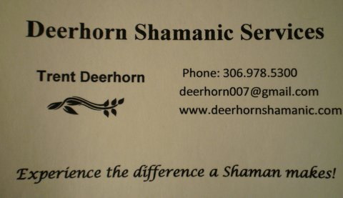

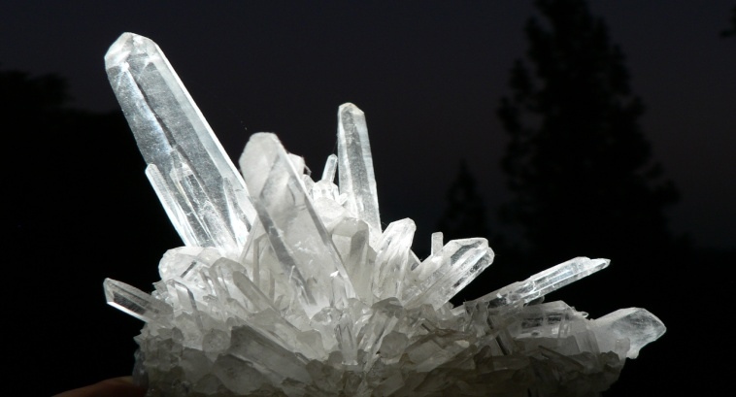
Medium-Healer
Ryan Hauser
(306) 270-0138
ryan.hauser@sasktel.net

A clean home is a true blessing! Trent Deerhorn

Face Time with the SHAMAN!
As part of my Shamanic Practice I have, for years, provided long distance healing work for people. This sometimes comes as an energy treatment and sometimes as a telephone counselling session. Well, now there is even another option available! We can now have sessions on Face Time and you can speak to me face to face! If you are interested in this option, simply email me at deerhorn007@gmail.com or phone me at (306) 978.5300 to make arrangements. Blessed Be!

Flight Newsletter Advertising Advertisements for Flight: A Living, Breathing Document of Consciousness
All ads must be in by the 20th of the month PRIOR to the issue that the ad is to be placed in. No exceptions. Send to deerhorn007@gmail.com.
Classified Ads:
FREE for article contributors
$25 for business card size
$35 for half page
$45 for full page
Events: FREE for Non-profit organizations and Article Contributors
$20 Profit organizations
Workshops/Classes
$35 half page
$45 full page

